**C programming and Data Structures**

**Kernighan and Ritchie 2nd edition, Neso academy, Code Vaults and MIT Advanced Data structure and algorithms.**

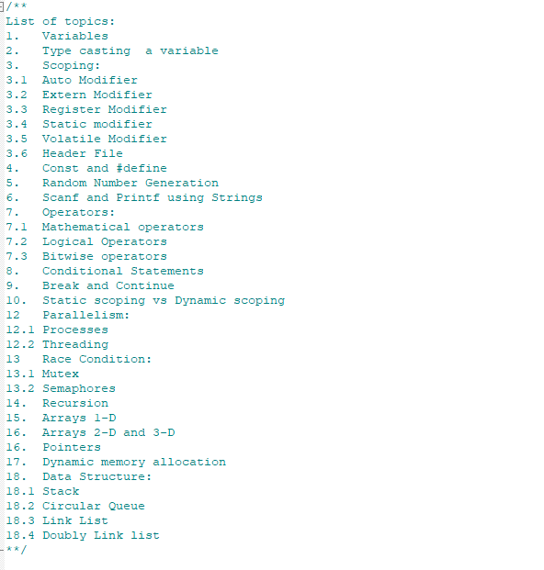

**Author:** Harsh Dubey

**Chapter 1: Variables**

**Variable names:**

**Variable:** Variable in C is something who’s value can change during runtime/execution.

**Declaration:** Rules for declaring the variables.

1. **First** character must be a **letter.**
2. **Underscore** counts as a letter.
3. **Upper and lower** are different names. X and x are different names.

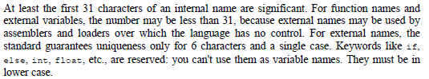

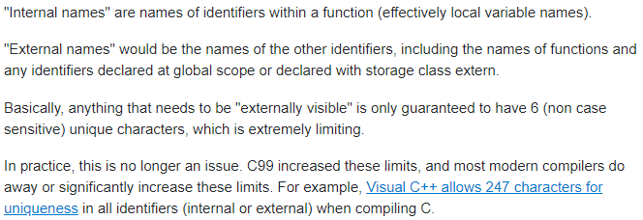

**Data type, size qualifier and sign qualifier:**

1. **Four** kinds of data types: **Char, int, float, double**

* **Char:** character whose size is **1 byte**.
* **Integer:** + or – whole numbers. Size is **4 bytes**.
* **Float:** Single precision floating point numbers or fractions (**7-digit precision**). Size is **4 bytes**.
* **Double:** Double precision floating point numbers (**16-digit precision**). Size is **8 bytes**.

1. **Qualifiers based on size:** Change size of data types.

* **Short and long** apply to **integers**. Typically, Int is 4 bytes, short int is 2 bytes and long int is 8 bytes. You can **omit Int** keyword, and the default is **int.**
* **Long** can also be used **for double**.

1. **Qualifiers based on sign:**

* **Signed and unsigned** can be applied to any characters or integers. Will change the range of the data type.

1. **<limits.h> and <float.h>** contain symbolic constant.

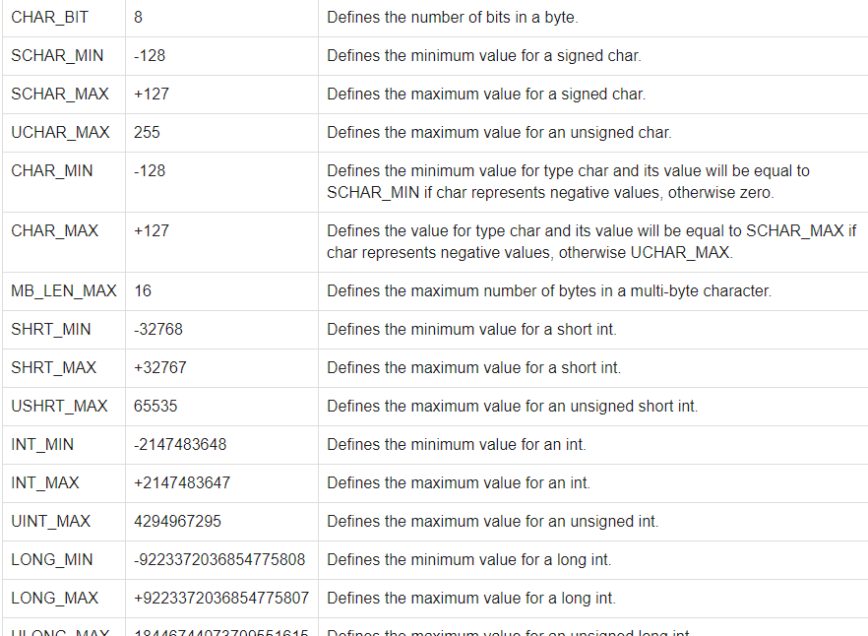

1. **Question:** What kind of **printing qualifier** you should use for all these **ranges**?

**Question: 2.1:**

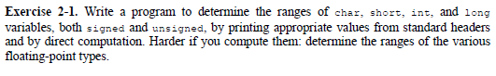

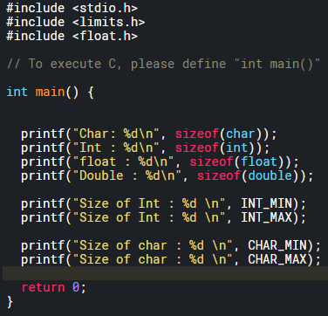

**Integer:**

1. Store’s integers (+ and -)
2. **Default is signed – “int x”**
3. Find size using” **sizeof** ” operator.

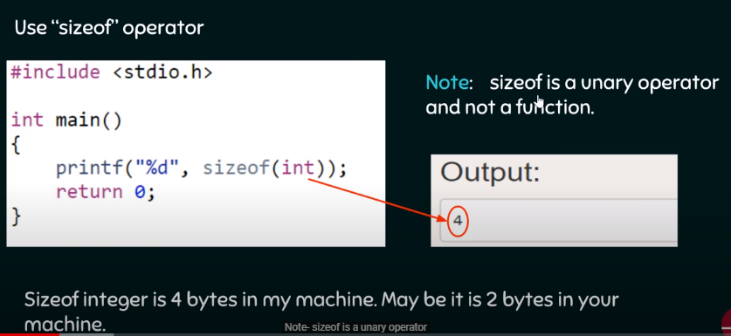

1. Find **range using <limits.h> .**

* **Unsigned** range is **0 to (2^n -1).**

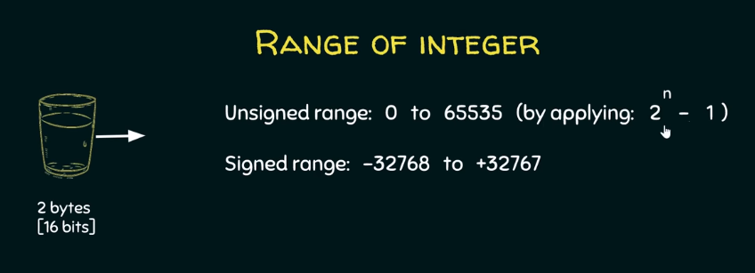

* **Signed** range is **(-2^(n -1)) to (2^(n -1)-1).**

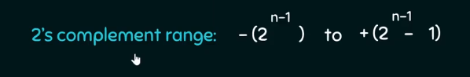

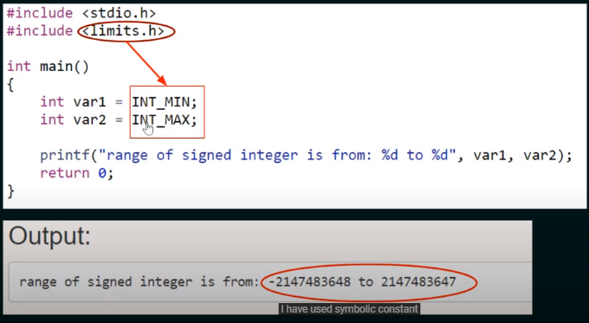

1. Print using **%d** for **signed** and for **unsigned** print using **%u.**
2. If printed using %d then only signed representation can be printed doesn’t matter if you’ve assigned it as unsigned or not.

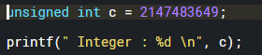

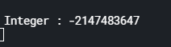

1. **Overflow:** Circle of integer repeats when values go beyond the range.

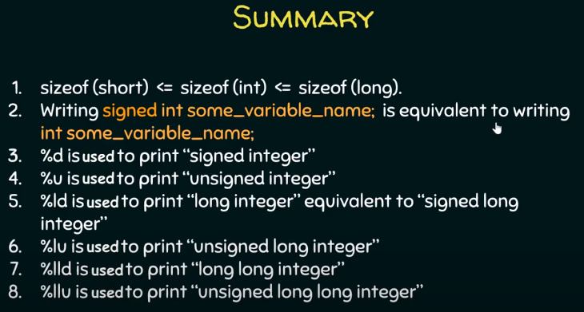

**Character:**

**Character:** Every character has a binary representation in machine.

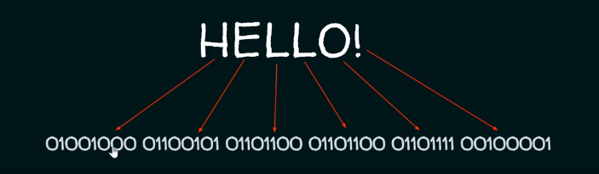

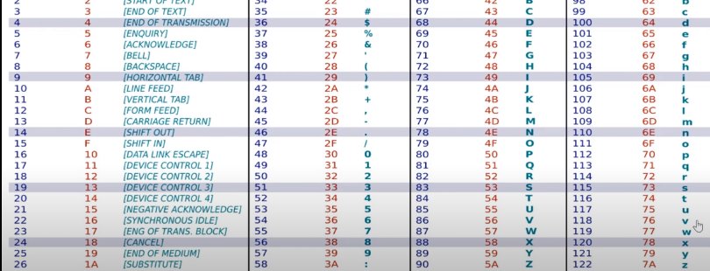

1. Character are ASCII encoded; everything must have a number. Hence, even **nonprintable character has to be encoded**, remember printing space on screen is what you used to clear the LCD in PIC 18. ASCII uses 7 bits.
2. Difference between **unsigned char and signed char**

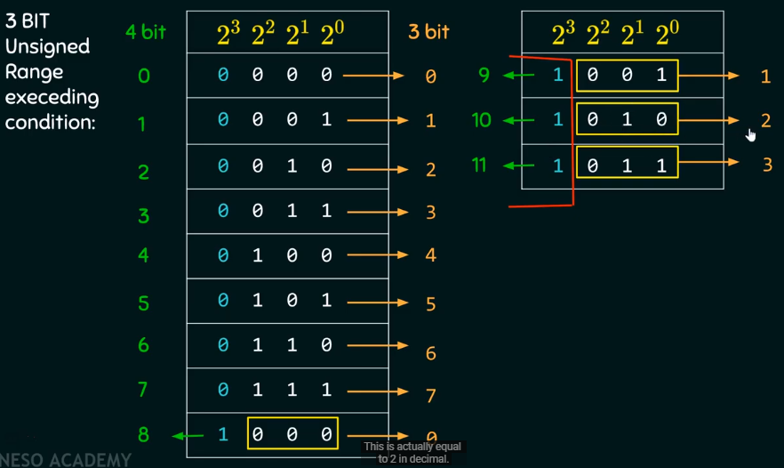

**Float, Double and long double:**

1. **Float: 4 bytes**; use %f to print it; by default %f and lf will print 7 digits. **%.16f** will print it upto 16 decimal places; however, float can only print upto 7 digits starting from before the decimal point.

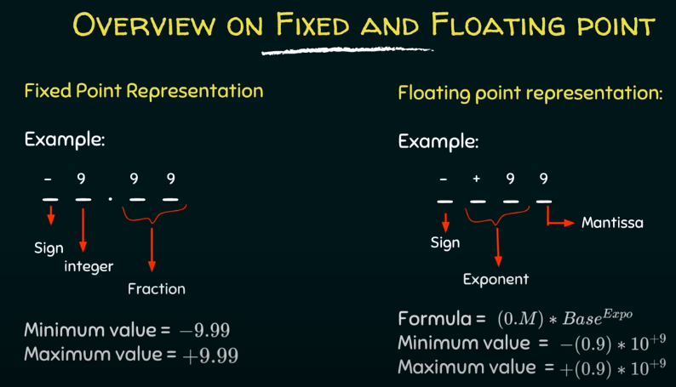

1. **Double: 8 bytes**; use **%lf** to print; double can print upto **16 so higher precision**
2. **Long double 12 bytes**; use **%Lf** to print; capital L; long double can pint **upto 19.**
3. **Why use Double instead of float: Size and precesion**
4. **To round up or round down use. f, nothing printed after the decimal.**

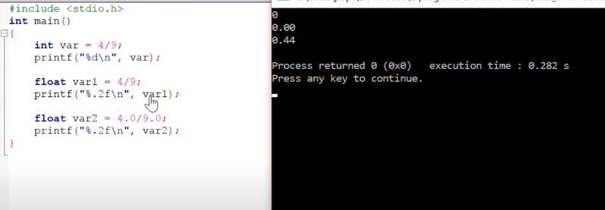

1. For **int,** 0 is printed there, since int will **truncate whatever is after the decimal point.**
2. For float is print 0.00 since **4 and 9** are an **integer value**
3. Therefore, just put **.0 at the end**, by default it is double. To make it float just put float at the end.
4. IEEE format:

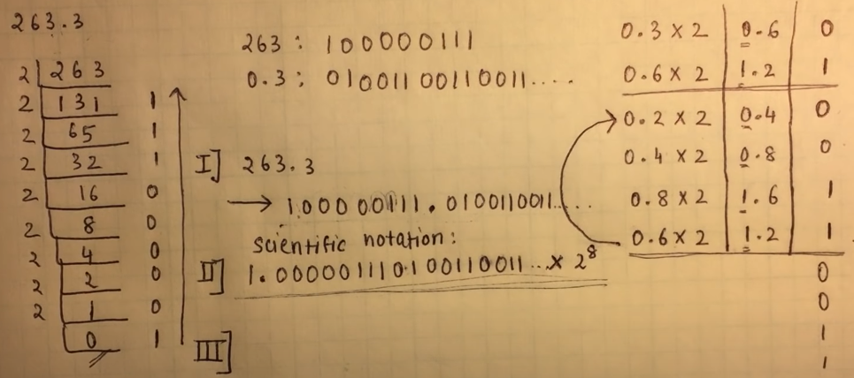

1. **Data types:**
2. **Exercise:** Reverse integer **Apple interview**
3. **Question**: Given a 32-bit signed integer, reverse digits of an integer. And if it’s more than the signed range then return -1.
4. 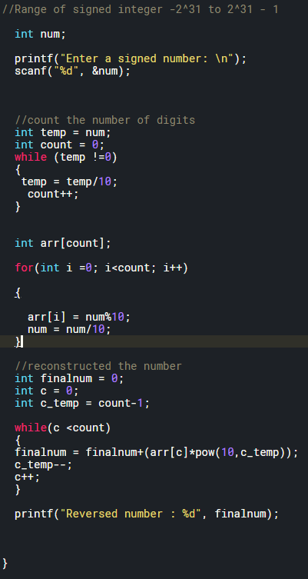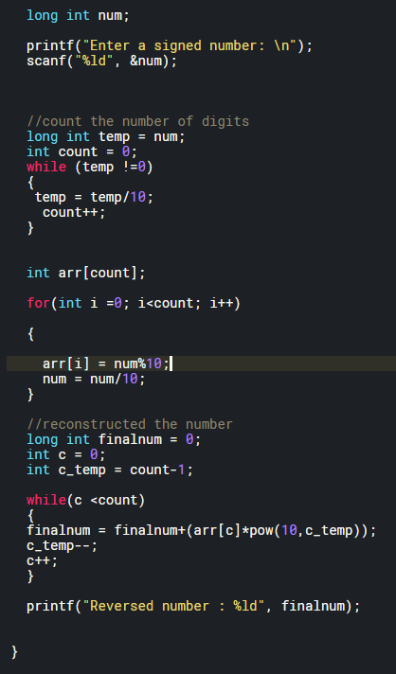
5. 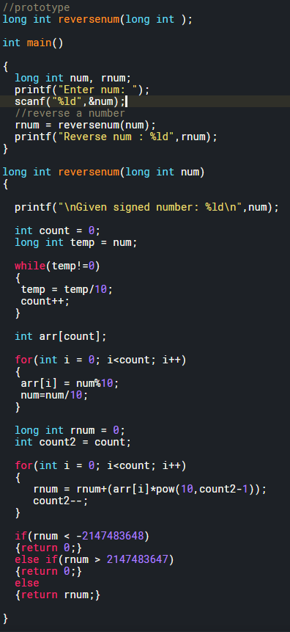
6. Question: Print size of all data types and print all different data types.
7. 
8. **Questions on datatype:** Neso Academy
9. 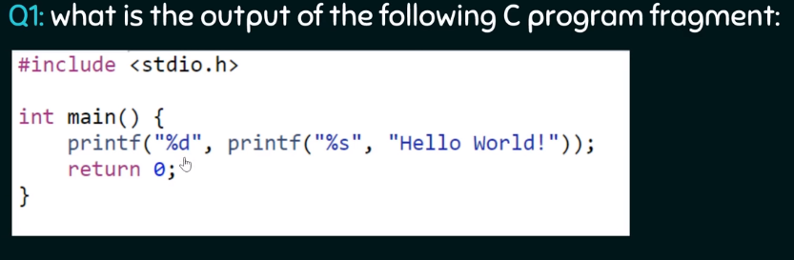
10. **Answer:** First It will print “Hello World”. Then it will print number of characters on the screen.
11. 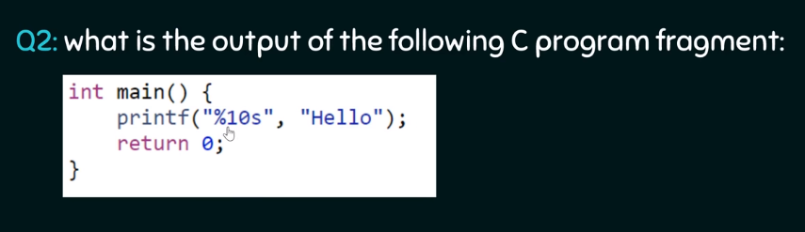
12. **Answer:** %10s means, print up to 10 characters wide. Therefore, 5 spaces+ Hello = 5
13. 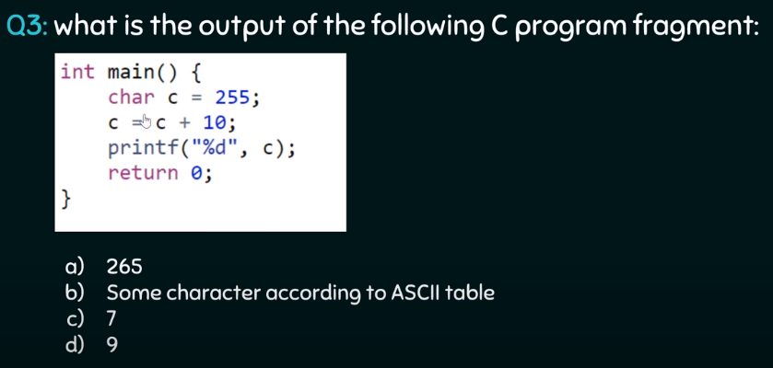
14. **Answer:** 9
15. 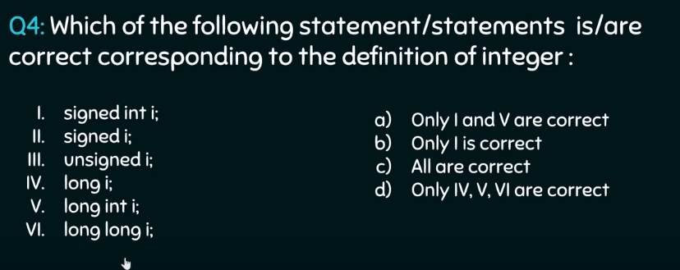
16. **Answer:** All are correct
17. 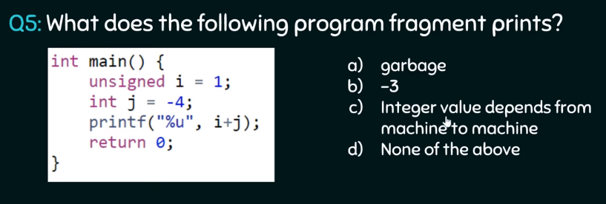
18. **Answer:** it will print unsigned of 2’s compliment of 3 i.e. 1111…..01 = 4294967293
19. **Other interview questions on Datatypes:**
20. 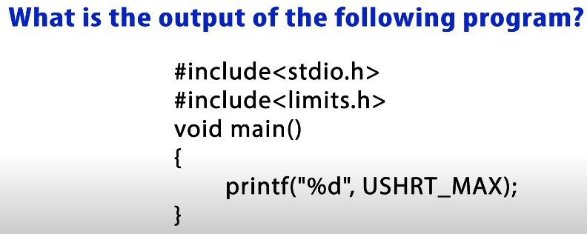
21. **Answer:** -1
22. 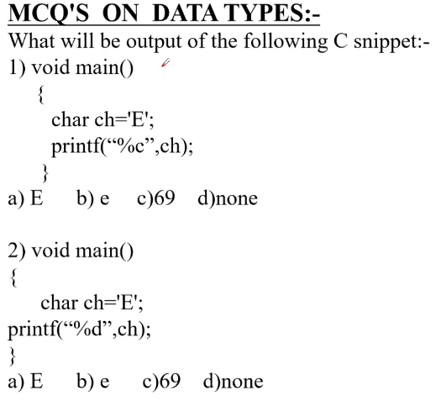
23. **Answer:** 1: E 2: 69
24. 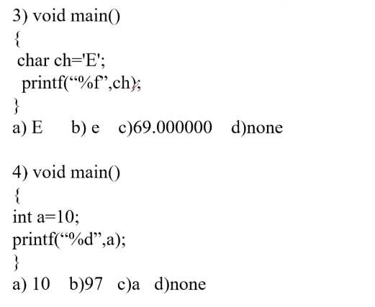
25. **Answer:** 3: none 2: 10
26. 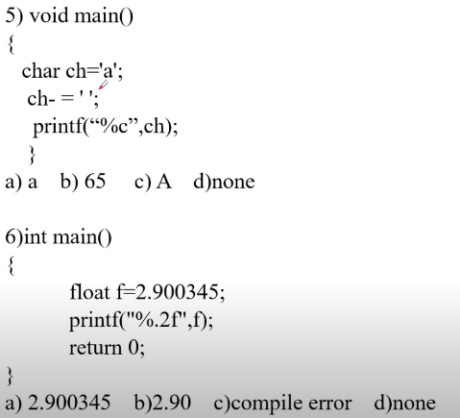
27. **Answer: IMPORTANT.** 5: A 6: 2.90
28. 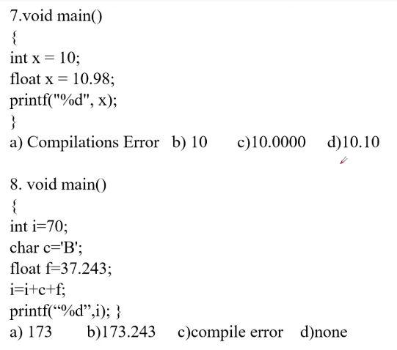
29. **Answer:** 7: Compilation Error 8: 173
30. 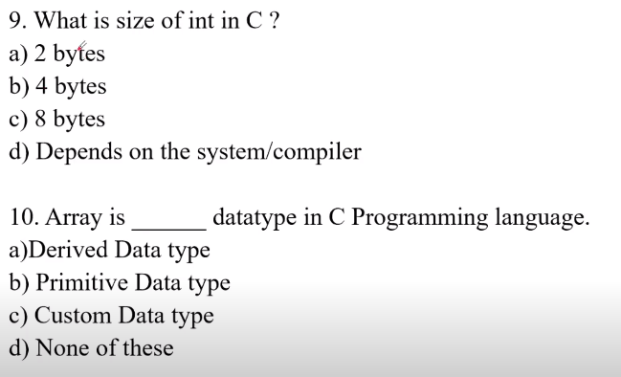
31. **Answer:** 9: D 10: A
32. 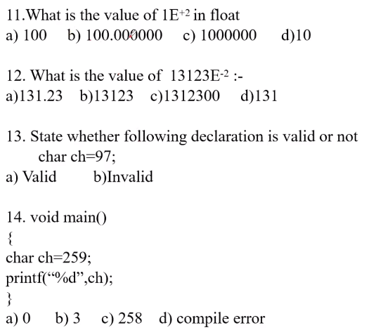
33. **Answer:** 13: A 14: B

**Type casting a variable:**

1. **What is type casting:** Type casting is better explained with an example.
2. **Let’s analyze the behavior of data types in C:**
3. Case 1: Printing a double/float using a %d operator: %d will truncate anything beyond the decimal.
4. Case 2: printing a interger using %lf: 0.0000.

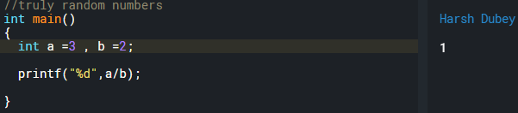

1. **Type casting:** C thinks if **int/int** or **int*int** will be a integer. That’s why type casting.
2. **Type casting operator:** Type casts **single operand** to the right.

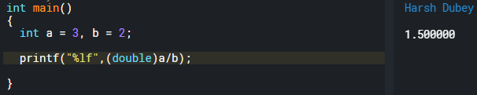

1. **Rules for type casting:** Smaller into bigger or same size into same size. Can type cast bigger in smaller. But then loss of data occurs.
2. **Use of typecasting and an example:**

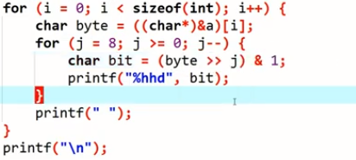

**Scope of Variable:**

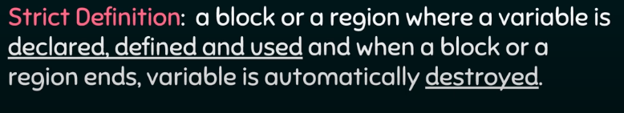

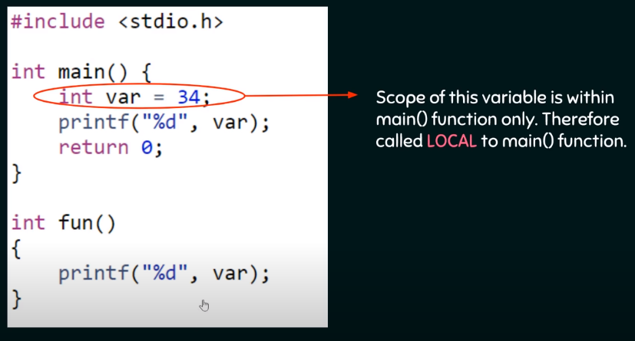

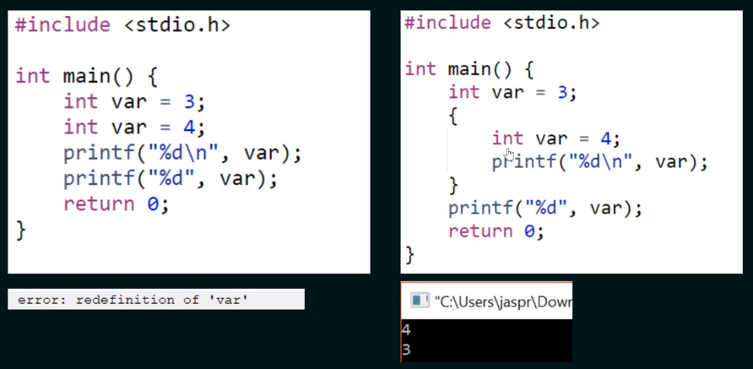

1. Block of code is not just separate functions but also can be created by using **curly brackets**.
2. **Global Variable:** Is also called external variable.

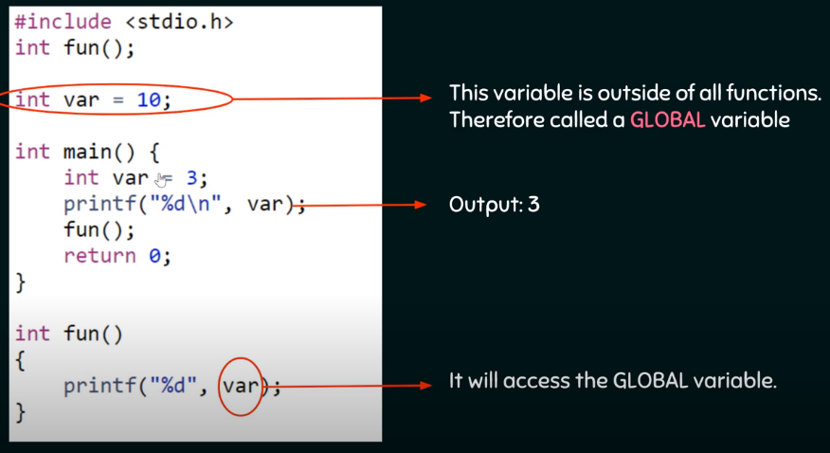

**Modifier:**

**Auto Modifier:** Automatically **destroyed.**

1. Every variable is a auto variable by default.

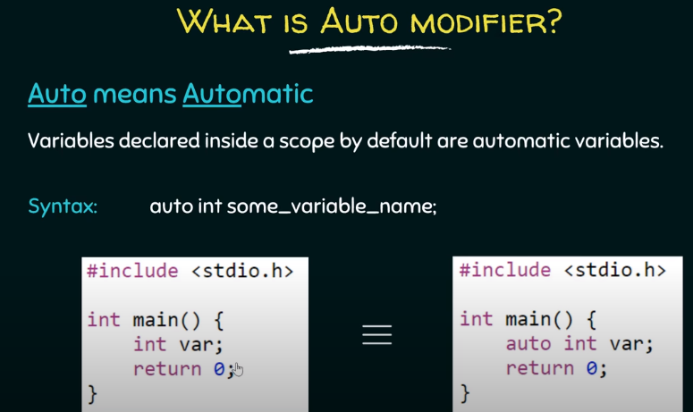

1. Declare an auto variable or a **normal variable and print it**, It will print a **garbage value**
2. Declare a **global variable** and try to print it. It will print **0.**

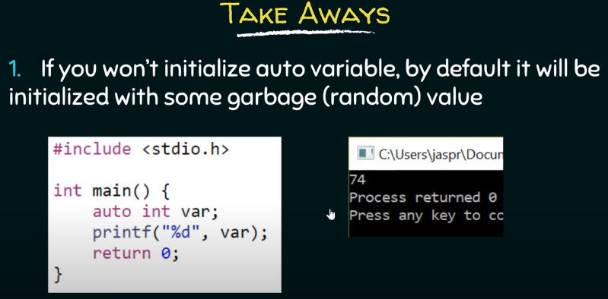 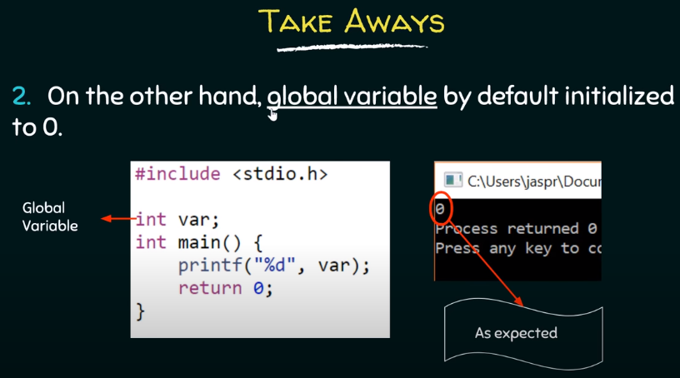

**Extern Modifier:**

Scoping rules:

1. **Why** need **scoping rules**? Bc the whole program of C **need not to be compiled at the same time**. We can have **different files** that are compiled at different times. And previously compiled routines may be loaded from other **libraries.**
2. Scope of **automatic variable**:

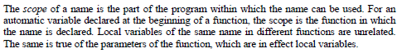

1. Scope of **extern variable and functions**:

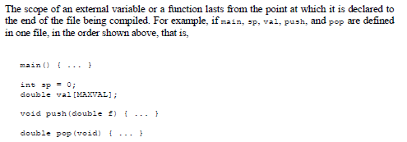

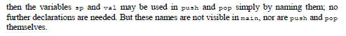

1. **Extern variable** in same file and **out of scope** declaration. Variable referred to before it is defined.

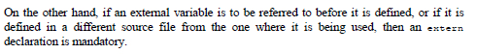

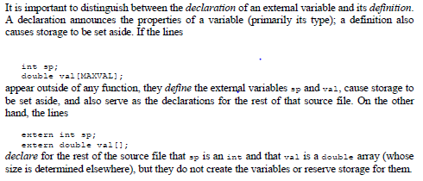

1. In **extern keyword** below, the extern declares the variable but doesn’t define it. Hence no memory space is reserved, hence no value is stored and hence no value is printed.

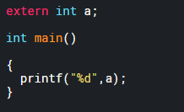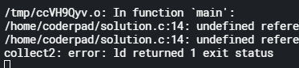

1. Let us define it out of scope now.

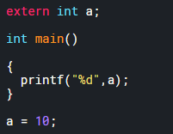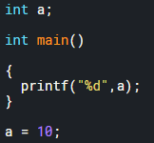

Output is 10 in both cases.

1. Let us define a global variable with extern.

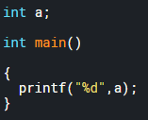

Output is 0 in this case. Since, it is a global variable.

1. Only one definition is allowed of extern variable.



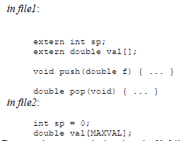

1. **Declaration means variable exists**, and **definition means book a memory space for** it.
2. Extern modifier: The variable is externally declared (out of scope) and defined in some other file. Therefore, don’t define it.
3. Who can modify the variable? - **Linker links all the files together**. Compiler compiles the file.

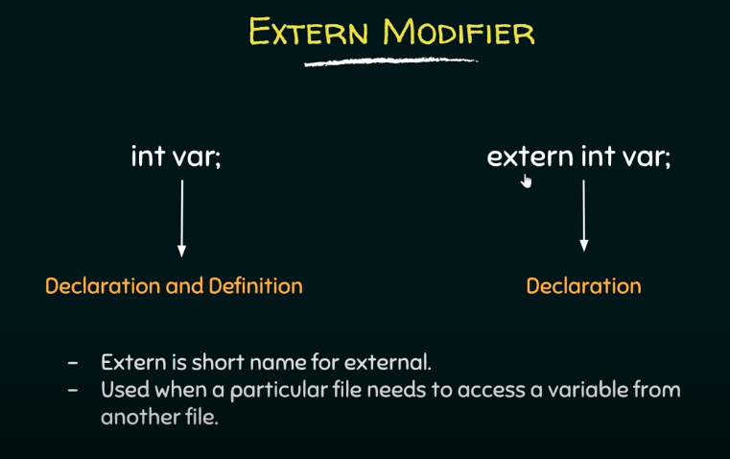

1. Extern just says to the block that the variable is defined out of scope. **Used when a particular file needs to access a variable from another file.**

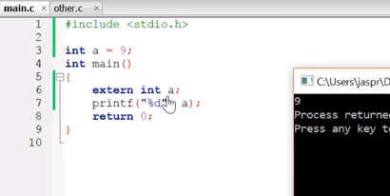

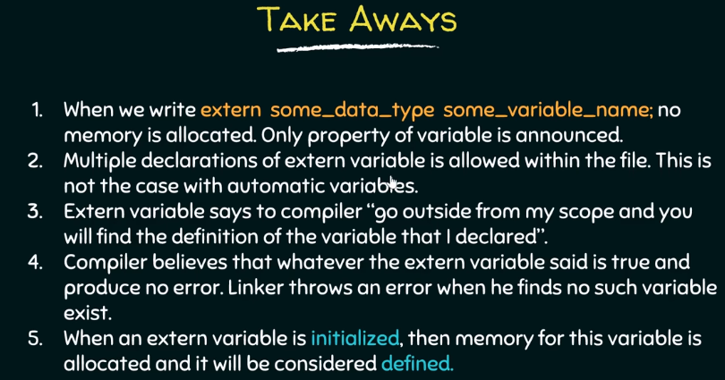

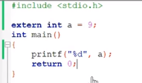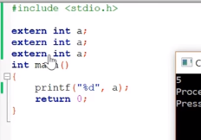

1. Multiple **declarations are allowed** but **multiple definitions are not allowed**.
2. Once the **extern variable is initialized** then memory for it is allocated and will be **considered defined.**

**Header file:**

Keep things centralized. Below picture explains it very nicely.

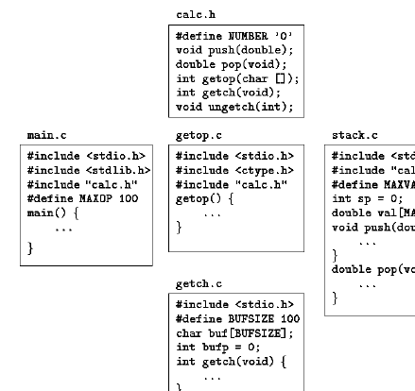

**Register Modifier:**

* 
* 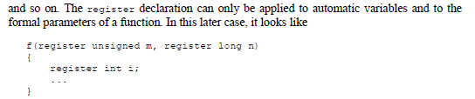

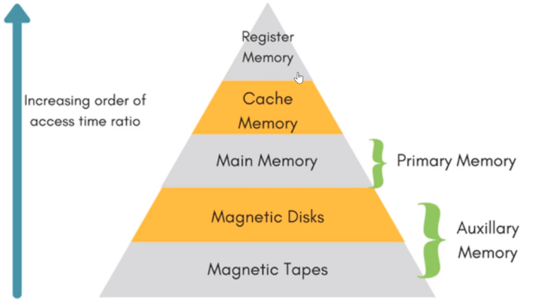

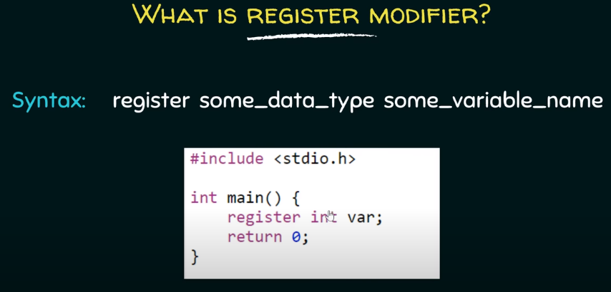

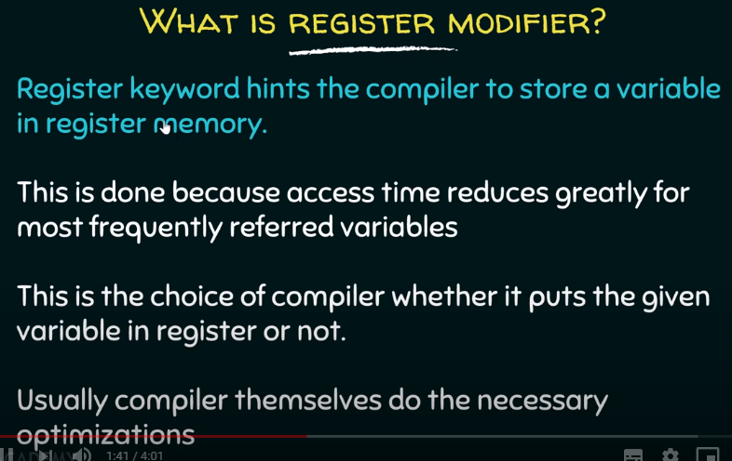

1. Whichever **variable needs to be accessed multiple times,** put that in register file. Since **access time is fastest** in it.

**Static modifier:**

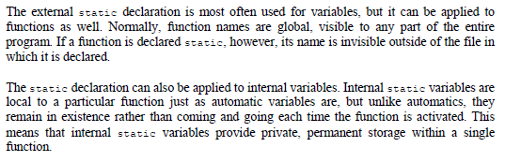

1. How to protect a global variable from other files? – Declare it static

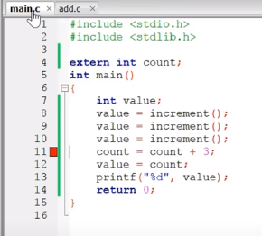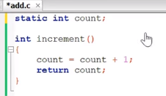

1. How to protect It from other functions within the same file? Declare it within the same function as static.
2. Static also makes the variable “STATIC” which means once it’s initialized with certain value within a function, then it won’t be reinitialized again if the function is called again.
3. By default, it’s initialized to 0, Just like global variable even though it’s declared locally.
4. And can’t be initialized using a variable.

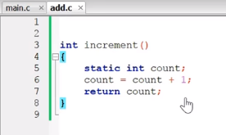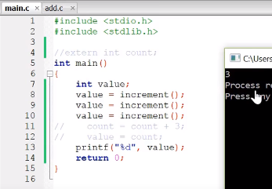

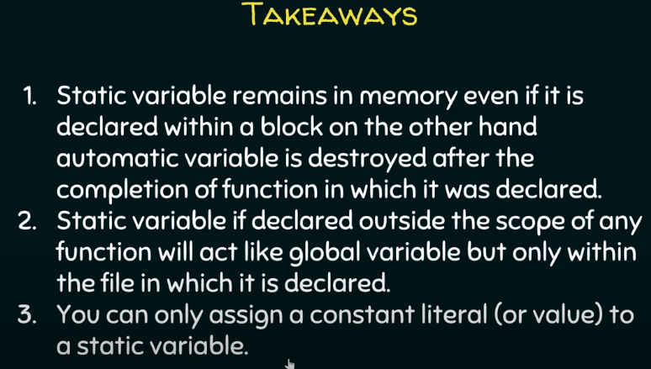

**Volatile modifier:**

1. **Why volatile:** Everything is fine until the bloody compiler optimizes the variable.

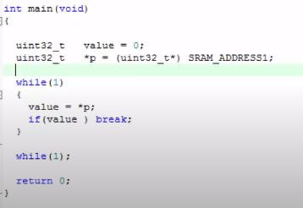

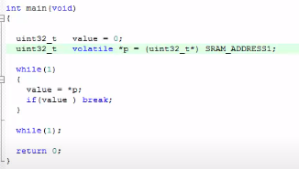

1. **Drawback of volatile keyword:** It can affect the variable if it is in the loop.

**Semaphore:**

**Why semaphore: To protect** from **volatile** keyword.

**What is semaphore:** Integer value/ flag/semaphore variable used to protect the running code.

1. **Counting semaphore:** P wait and V signal.

Semaphore = -3

P4, P5, P6

Entry Code

Critical section

P1, P2, P3

Exit Code

1. **Entry code:** P – wait – down.

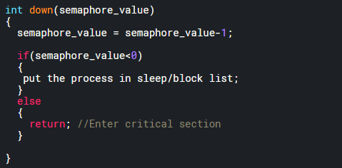

1. **Exit code:** V – signal – up.

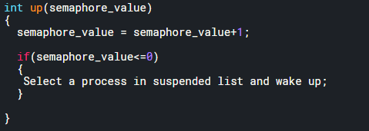

1. **Binary semaphore:** P wait and V signal.

Semaphore = 0/1

P2

Entry Code

Critical section

P1

Exit Code

1. **Entry code:** P – wait – down.

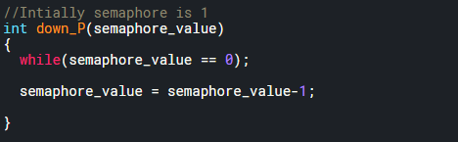

1. **Exit code:** V – signal – up.

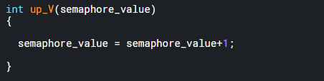

**Processes and Multi-processes programming in C:**

**What is Process: Main process** is a process. Can create child process using **fork ()** function.

1. **Header file: #include <unistd.h>**
2. **Fork:** Create a new timeline from the **line of fork instantiation**. Two **fork () will create 2 to power 2 processes timeline.**
3. **Fork** returns a **integer ID**. **Baby timeline** has a **id** of **0. Father timeline** has a **non-zero ID**.

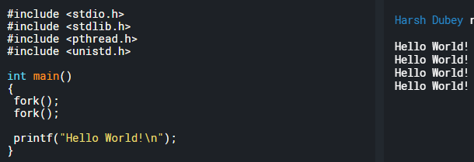

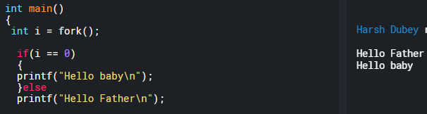

1. **How to create 3 processes?**

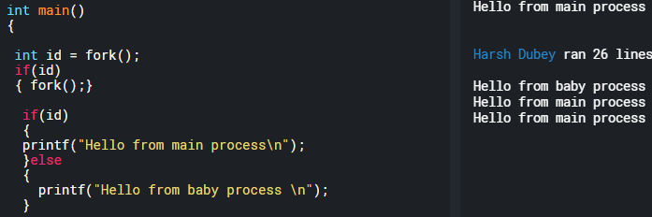

1. Create a **fork process** and print first **5 number of 1-10** using **baby process** and then **next five using main process: fflush(stdout);** and **wait();**
2. Main process is executed first here, but the idea is that **both main process** and **child process** are **happening at the same time.** **fflush(stdout)** will **print** the **characters as they are written in the LCD buffer. O**therwise it will wait for it to fill the buffer and then print every thing.

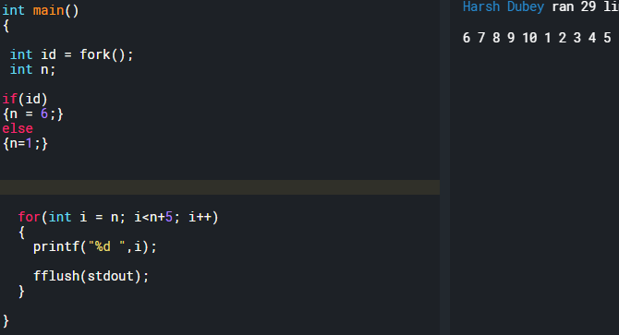

1. To make the main process wait. Use **wait()** function.

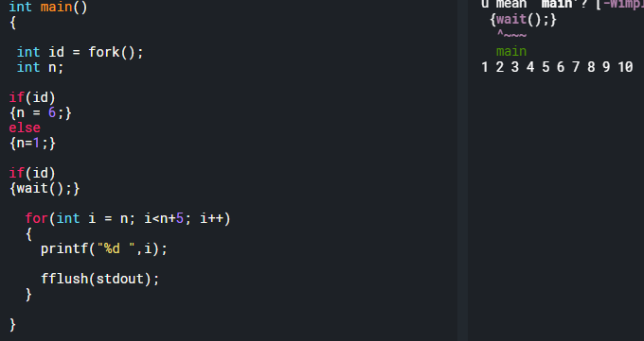

1. **How are process id’s assign?** 2^fork(): 00,01,10,11
2. Child of child = **0,0**
3. Main: **1,1**
4. Whatever **Id the child is born of will be Zero**.
5. **Rest whatever is left the child will inherit**.
6. **Pipe** the process: Transfer **data between the processes.**

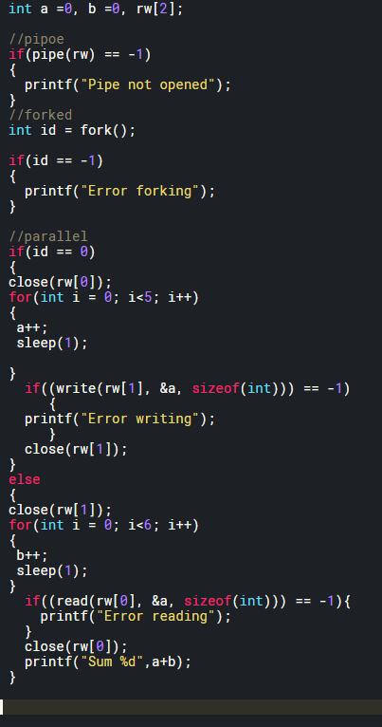

1. Ex: Find sum of array by exploiting multiple processors on your system
2. In the below example: Not **everything is faster** with **parallel processing.**

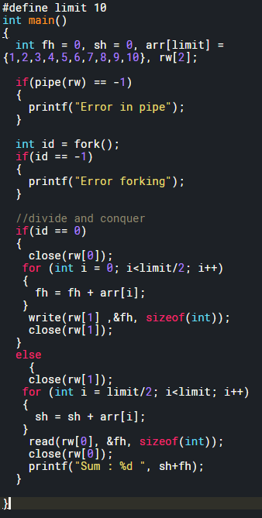

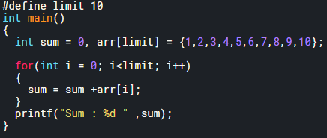

1. **Piping with more than two processes:**

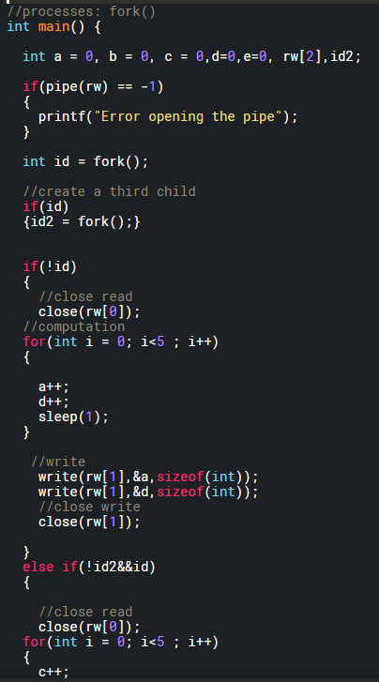

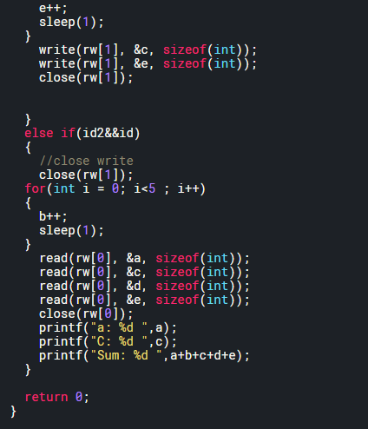

**Threading in C:**

**What is threading:**

1. **Pthread_t : API** will store information about the thread.
2. **Pthread_create: Create Thread:** look at the image for more understanding.
3. **Pthread_join: Wait ();** from process. Will wait for the function to execute and send the **return value.**

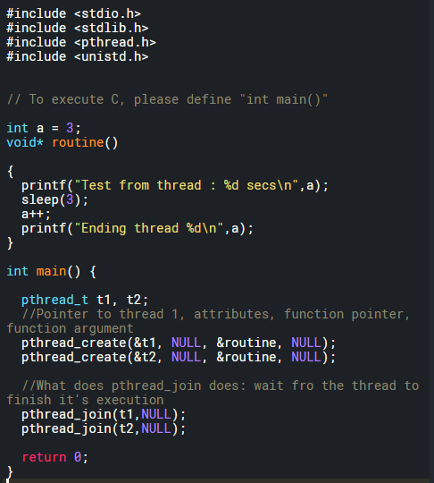

1. **Difference between Threads and Processes:**
2. Processes: Different ids, Threads: Same Id.
3. **Single process can** have **multiple threads**, but **single thread** **can’t** have **multiple processes**.
4. Processes: **Copied resources.** Threads: **Shared Resources.**
5. **Race conditions:** Below is called the race condition.
6. Figure 2
7. Creation of threads. If less conditions are there, then by the time the 2nd thread is create the first thread is already done with its work.

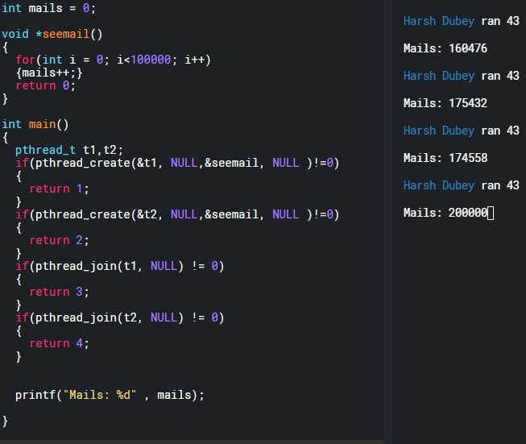

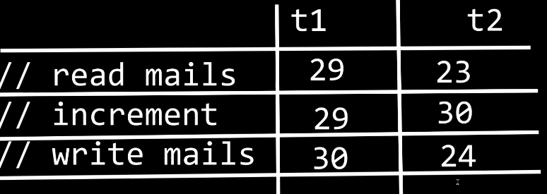

1. **Mutex:** Way to **solve** a **race** **condition:**
2. **Declare: pthread_mutex_t**
3. **Define: pthread_mutex_init();**
4. **Destroy: pthread_mutex_destroy();**

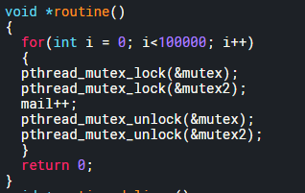

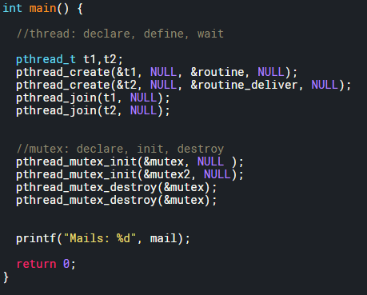

1. **Creating multiple threads using for loop:**

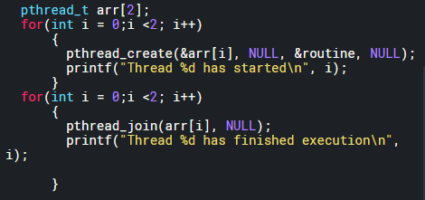

1. **Get a return value from thread:** pthread_join (Study pointer and memory allocation for that)
2. **Pass arguments to thread: to 18**

**19. Deadlock: Nothing** will **execute.**

1. **Single deadlock:** Lock the same mutex twice.
2. **Swap deadlock: rand()%2** could lead to dead lock.
3. **Two thread deadlock:** Two threads executing different functions and locking two different deadlocks in inappropriate order.

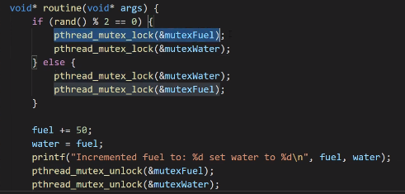

**20. Recursive Mutex:** A mutex that can be **locked multiple times** is called a **recursive mutex**.

1. **Why recursive mutex?** Recursive functions need recursive mutex, since the function calls itself.

**21. Semaphore: Binary and counting semaphore:** Semaphores are basically used to create ques. Binary semaphore acts like mutex but doesn’t give ownership to one thread.

1. **How to create a semaphore:** Declare, init, destroy







1. **How to use:** sem_wait(&semaphore) : sem_post(&semaphore)

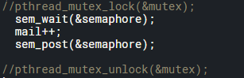

1. **How to change it to counting or binary?** In init use to 3rd argument as n value for semaphore.



1. **How to add multiple process?** In init use to 2nd argument as number of processes.

**22. Semaphore vs Mutex:** Semaphores doesn’t give ownership to any one thread, mutex gives complete ownership. Basically, another thread in the program could unlock the mutex locked by a different thread.

23. **Practical example of semaphore:** Game server example

24.

**Random number generation: <stdlib>**

1. **Random number generation:** using rand() and srand().
2. **Rand() :** Will give you pseudo random number. If the code is executed multiple times than we will get the same set of random numbers.
3. **Srand(x):** We can seed rand() with a **unsigned integer** and get a new pattern. But again, the new pattern will repeat if program executes multiple times. Rand() by default runs with **seed of 1.**
4. Seed **Srand(x)** takes 32 bit value with **time (NULL). #include<time.h> %6 will give numbers from 0 to 5.**
5. **Time() takes in a pointer and returns the 64 bit time value and store it in that location of the pointer.**

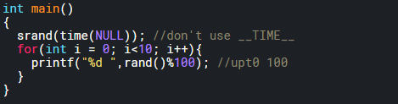

1. **Print random number in positive range:**

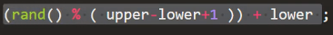

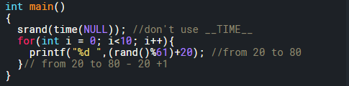

1. **Print random numbers in negative to positive:**



1. **Floating point random number:** To generate a random floating point we need to do math. **Rand() will return an integer** hence type cast it and divide it by another integer to get random floating point value.

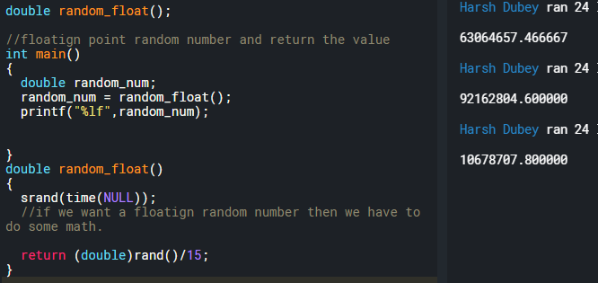

1. **Floating point numbers from 0 to x:**

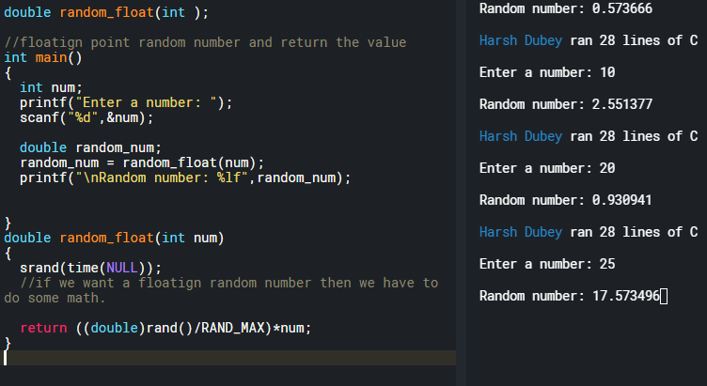

1. **Floating point random number in a range:** Just add the upper value to the return. If num is 5 then the range will be from 5.5 to 5.5+num.



**Constant: #define and const:**

**Macro:** Defining constant using #define.

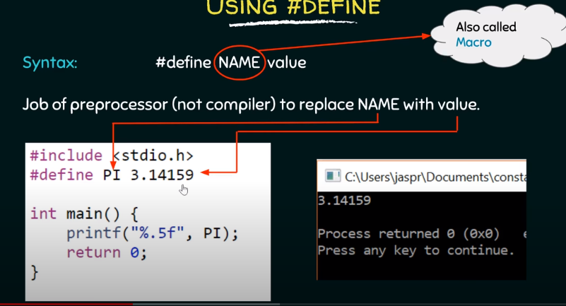

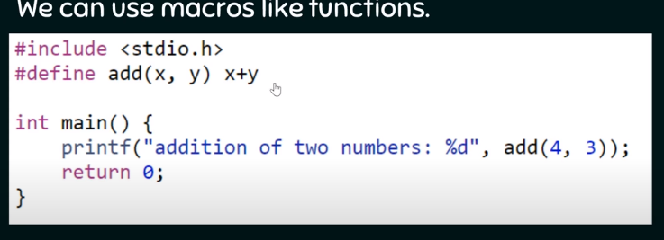

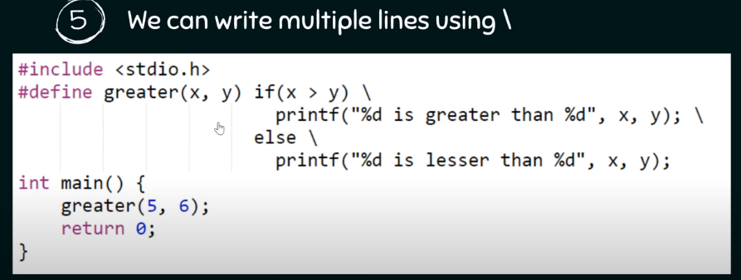

1. You can use macros to print and compute. But code blocks don’t let ya just compute.
2. Below is not allowed.
3. 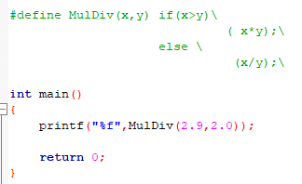
4. Below is allowed.

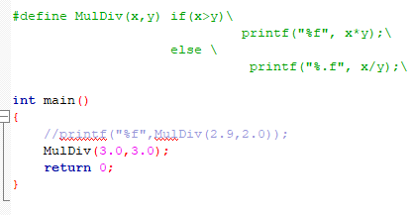

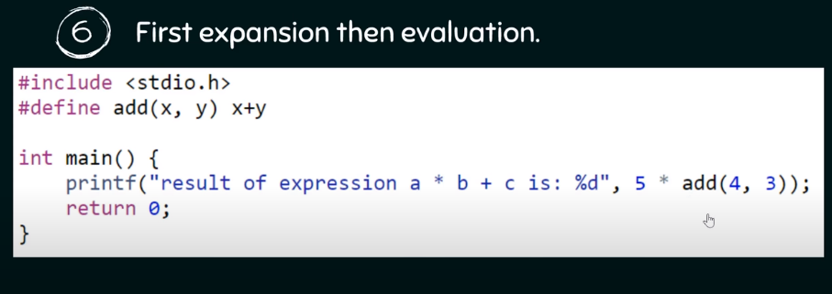

1. It will print 5*4+3 = 23, not 35

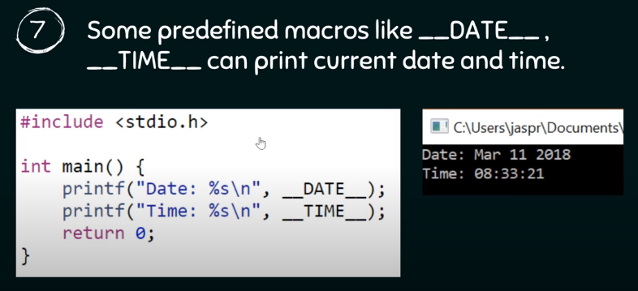

1. Macros to print date and time.

**Defining constant using Const:**

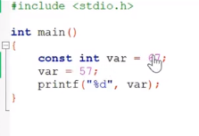

1. Can’t change the value later in the code.

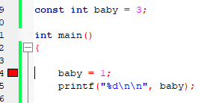

1. But can be reinitialized.

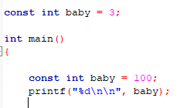

1. But can’t be reinitialized in the same scope.

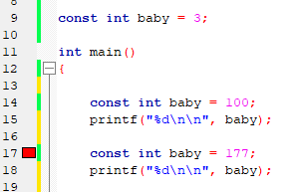

**Questions:**

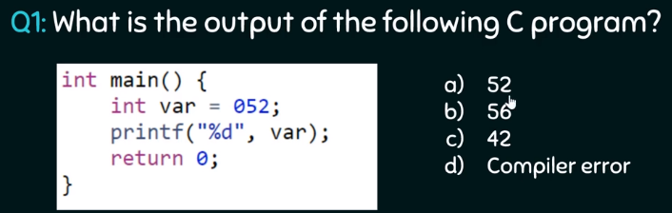

**Answer:** When we put zero in front of any value then we are making it a octal value.

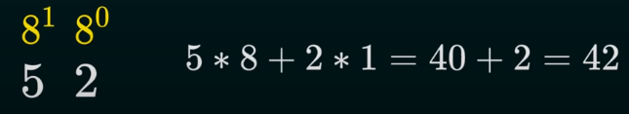

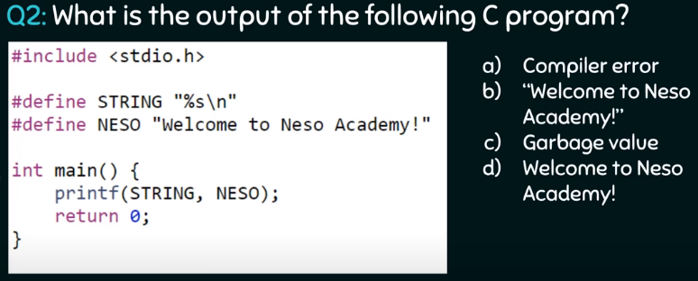

Answer: D, no double quotes

**Scanf and Printf and File terminal I/O operations:**

1. **Scanf and how to read a line of text in C?**
2. **Using scanf with “%s” :** Will terminate after a “Space”. Will not take what’s written after the space.

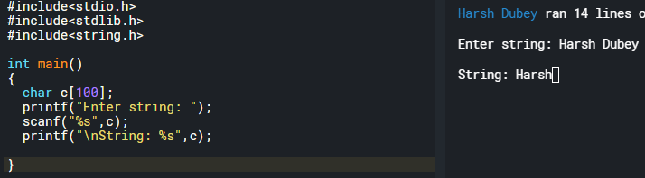

1. **Use scanf with [^\n] operator to accept the space:** This will tell the scanf that take everything before the \n.

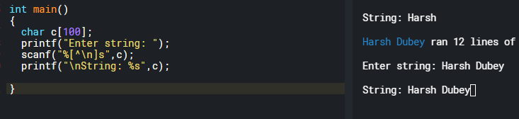

1. **But problem comes when two string are supposed to be taken from the user:** Since the old \n from the display buffer is not taken out. The [^\n] reads the \n from last string and the terminates.

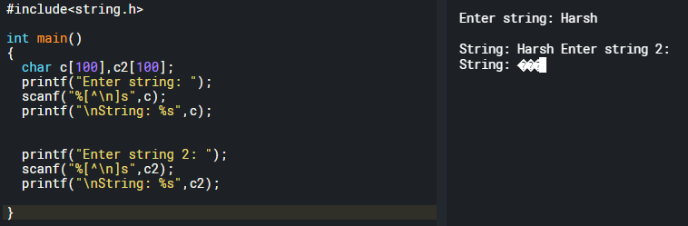

1. **How to fix this:** remove the \n from the buffer by using **getchar()** function to remove \n. However, bounds of the array are still insecure.

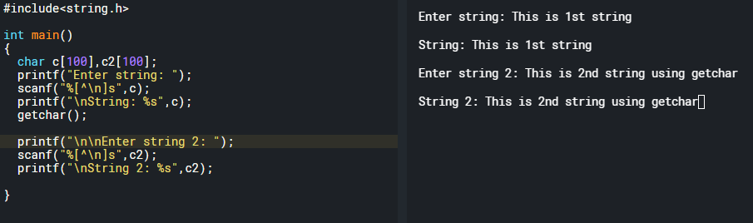

1. **We can secure the size of array by using scanf:** If we type extra characters then it won’t store in the string, but it will store that in the display buffer.

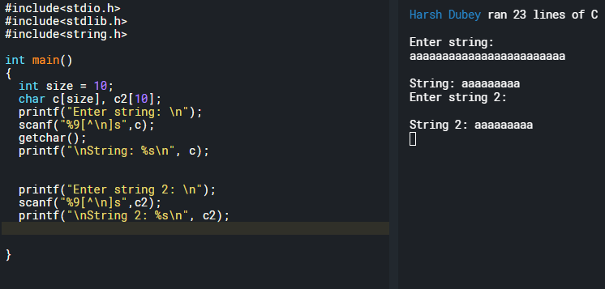

1. **However we can use something better to secure the bounds:** fgets(array, number of characters, stdin);
2. **Caveat:** It takes enter as an extra character. Notice the string length.

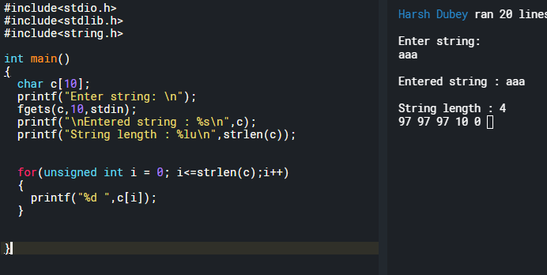

1. **Fix this by putting 0 at strlen – 1:** But now the string will only accept 8 characters.

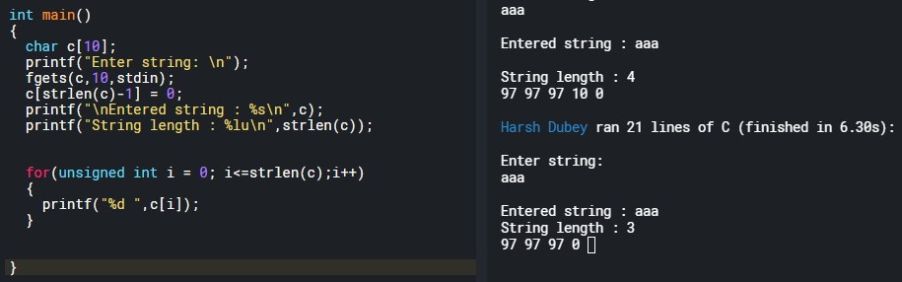

1. **Working with scanf and fgets():** scanf() leaves \n and “enter” that needs to be cleared if scanf and fgets have to be used together. Use fgetc() to remove the **enter.**

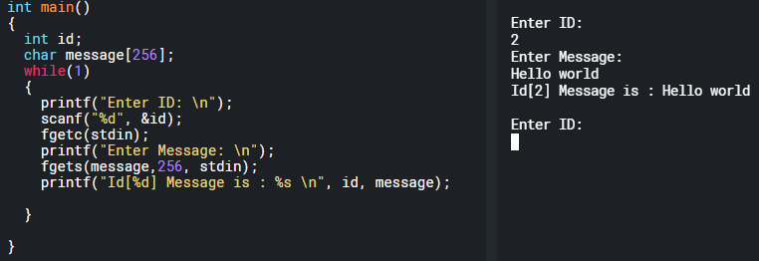

1. **Printf:**
2. Align the printed numbers to the right? By default, everything is aligned to left. **Pad it by some constant number.**

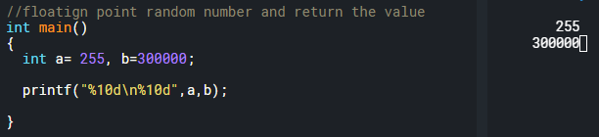

1. **Print Hex:** Hex : %x: small hex and %X: capital hex and %#x: 0xhex

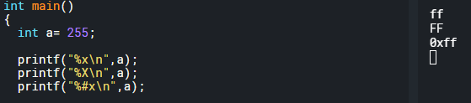

1. **Print address of the variable:**

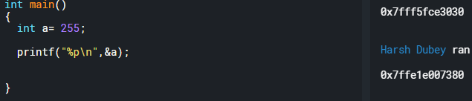

1. **Print oct:** use %o.
2. **Reverse a string using fgets and scanf:**
3. **Fgets:**

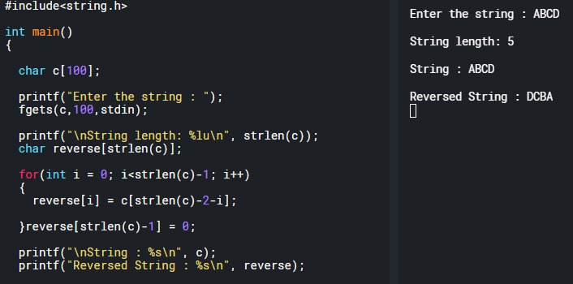

1. **Scanf:**

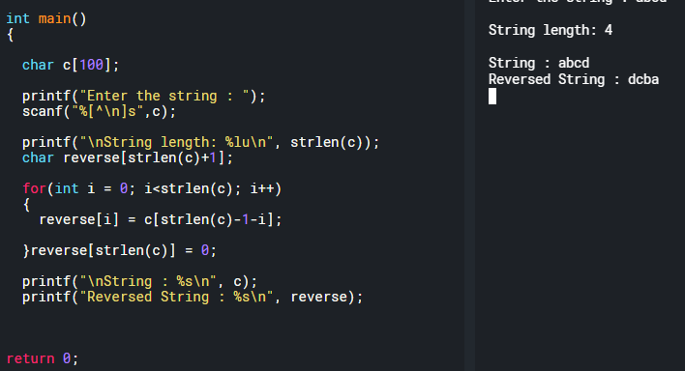

1. **Getc, getch, getche, getchar :**
2. **Getc and getche:** are basically obsolete.
3. **Getc(stdin)/fgetc(stdin):** basically, just gets a character form the screen and returns it.
4. **Getchar():** is basically getc(stdin)
5. **Putc, putch, putchar():**
6. **Putchar():** Takes and integer and then converts that to a character and prints it. Also, takes in character and prints it.

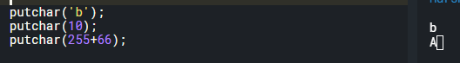

1. **Putc(): putc(‘e’,stdout);** takes two parameters, one is the character and other is the stream to write to. Stream, i.e., input /output.
2. **Return value of putchar and putc:** is the character they print on the screen.
3. **Putc(‘e’,stdin):** Will return an EOF.
4. **Ungetc(c,stdin):** To read what’s in then output buffer and then put it back in input buffer.

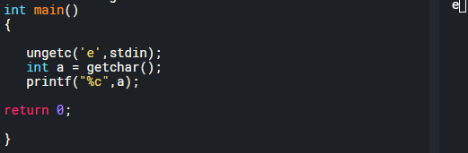

1. **Gets() vs fgets():**
2. **Vulnerability of gets() and a good example to understand memory layout and type casting:**

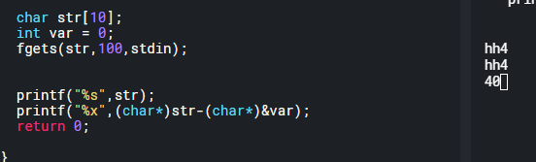

1. **Printf: 32 different functions**
2. **S – buffer:** Example: sprint: write formatted string to a buffer.

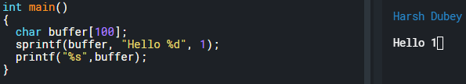

1. **N- buffer size:**

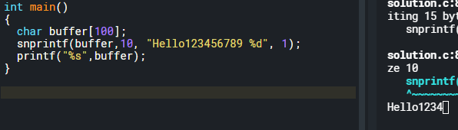

1. **F – file or stderr:** you can open a file and write to it then and there i.e. fprintf.



1. **_s : safer version of fprintf:** Used for safer file operations.

**Questions**

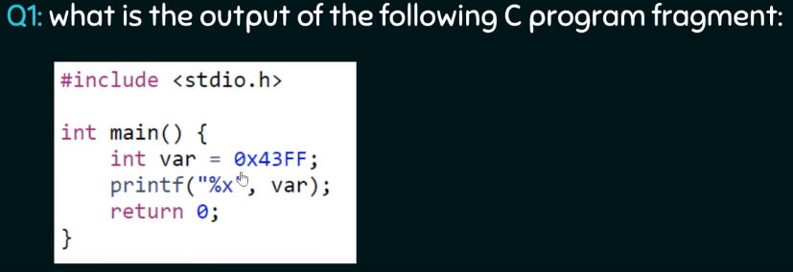

Answer: %x is used to print out hex

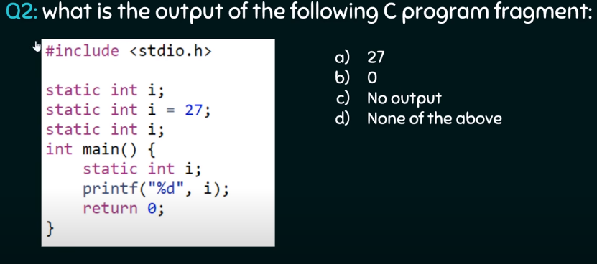

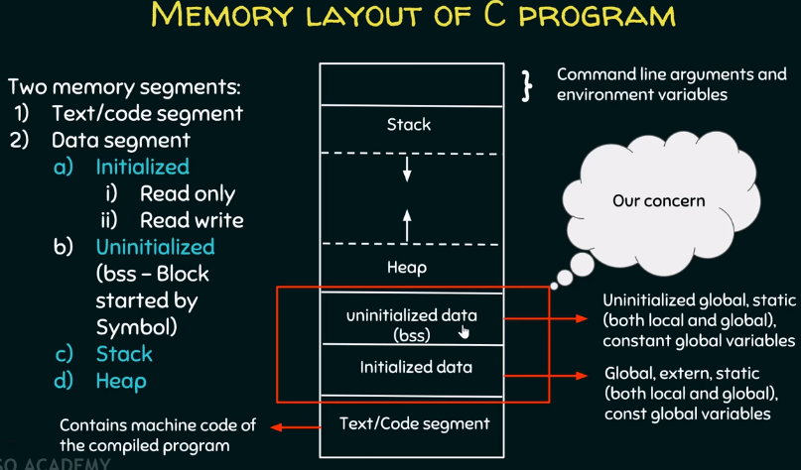

**Operator in C:**

**Arithmetic Operators:**

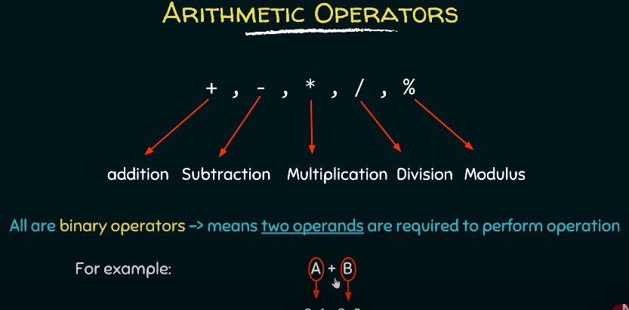

1. Modulus = remainder

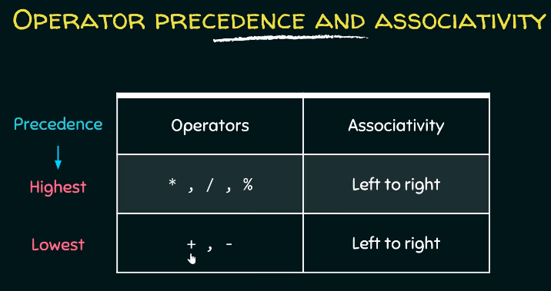

1. Precedence is from top to bottom first. And from left to right
2. Remember MDM for multiplication, division and modulus.

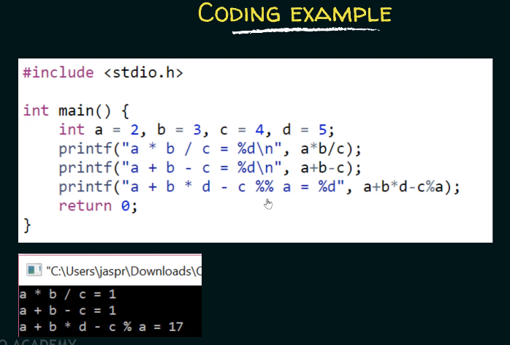

1. Look at the 3rd one and tell why the

**Increment and decrement Operators:**

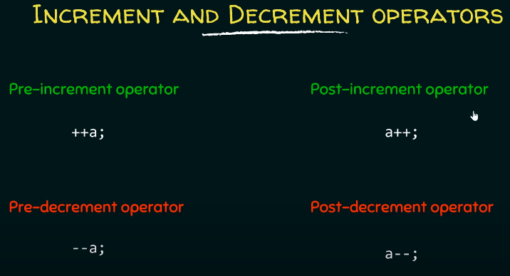

1. **Pre-increment (++i)** − Before assigning the value to the variable, the value is incremented by one.
2. **Post-increment (i++)** − After assigning the value to the variable, the value is incremented.

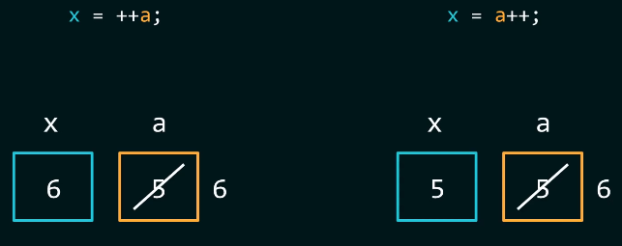

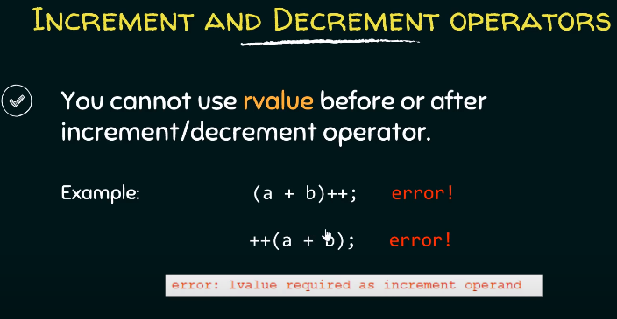

1. Lvalue: should be a variable that has an identifiable location in the memory.
2. Can’t be anything
3. Rvalue or right values are usually a expression or function that can return some value.

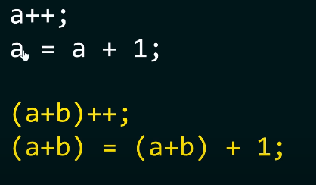

**Questions:**

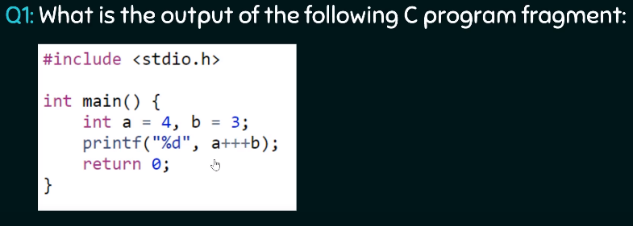

1. Lexem analyzer is analyzing lexemes from left to right.
2. Compiler will analyze valid lexemes and then assign them tokens

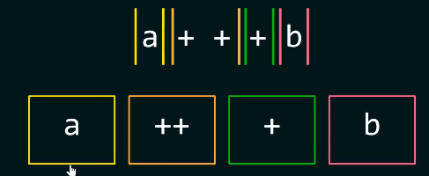

1. Post increment operator in terms of a equation : analyze the equation and then increment “a”.

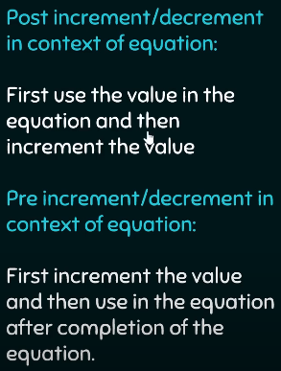

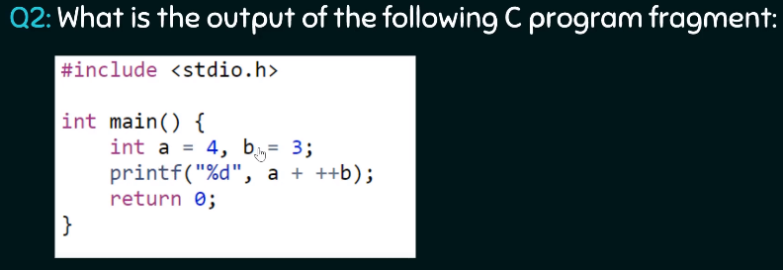

Answer: 8

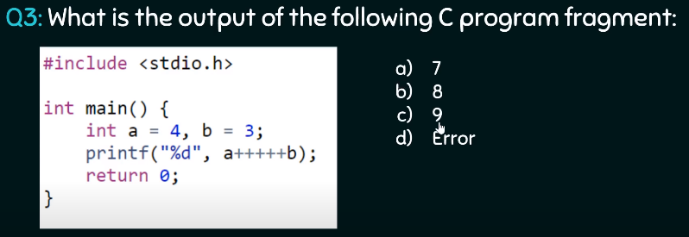

Answer: **Very important question.** Remember Lvalue concept. A++ = (a = a+1)++. **WRONG**

**Relational Operators:**

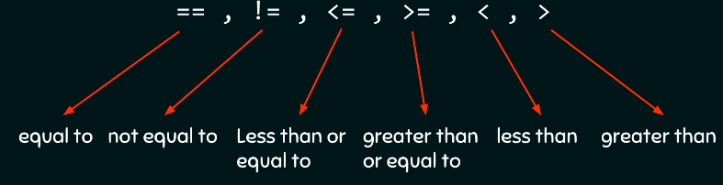

**Logical Operators:**

**Why logical operators:** Idea is to **optimize the code**. Maybe you are executing a lot of code and you want to decrease it. Then all you got to do is optimize by some sort of logical operation.

1. **And &&:** You are looking for conditions to be true by checking if **both operands** are **existing** or not. Any number that exists means it’s true.

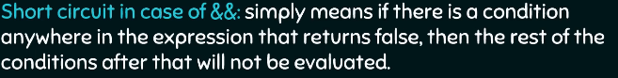

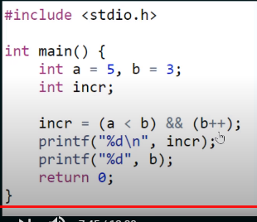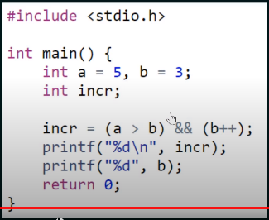

1. **OR ||:** You are looking for conditions to be true by checking if **anyone operands** is **existing** or not. Any number that exists means it’s true.

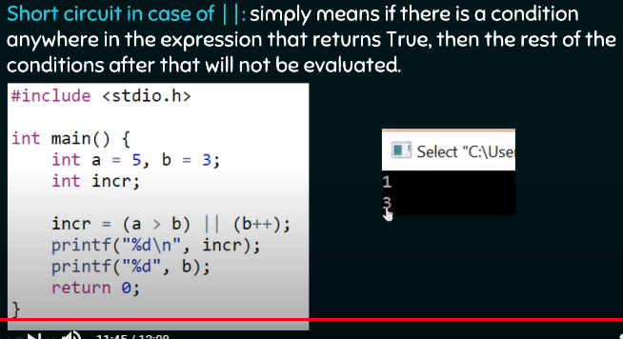

1. Look at the diagram below to understand short circuit for both && and ||

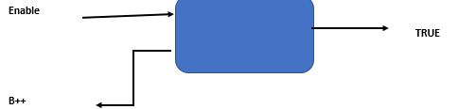

1. **In case of &&** if **Enable** is **high** **then B++ will BE looked** at to produce true. If enable is low, then FLASE is the output.
2. **In case of ||** if **Enable** is **high** **then B++ will NOT be evaluated** since, no need in case of OR. One high will produce TRUE.

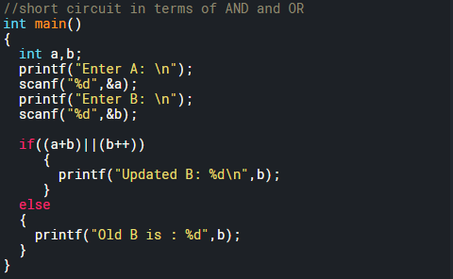

**Bitwise Operators:**

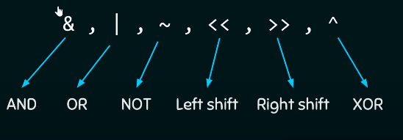

**Bitwise AND:**

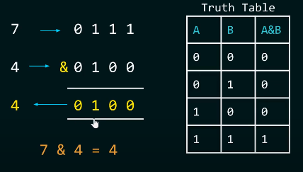

**Bitwise OR:**

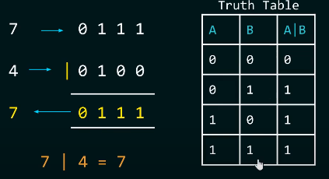

**Bitwise NOT:**

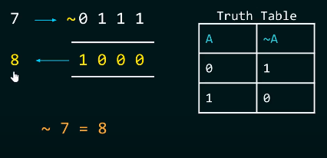

**Bitwise XOR:**

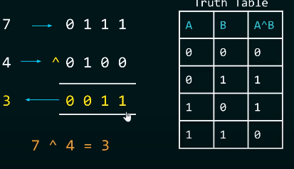

**Difference between Bitwise and Logical:**

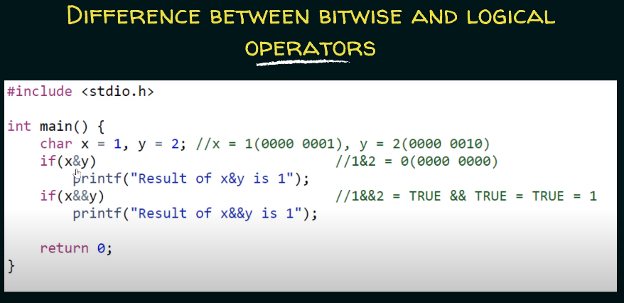

**Left shift operator:**

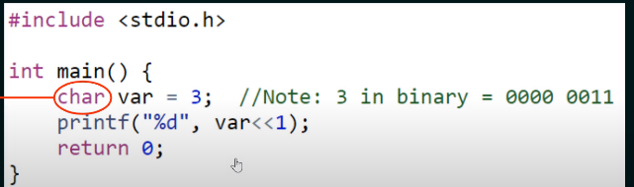

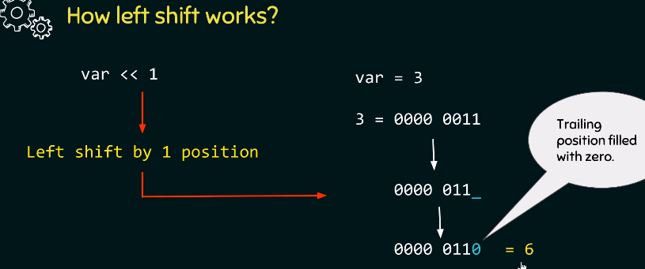

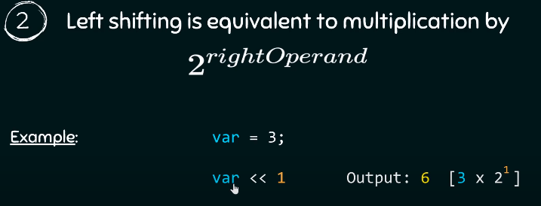

**Right shift operator:**

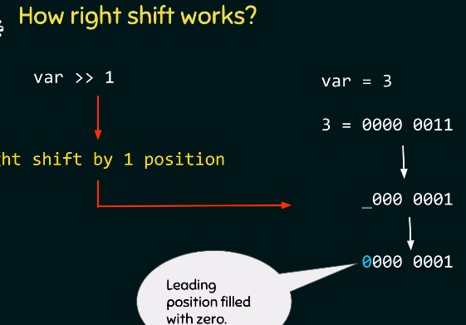

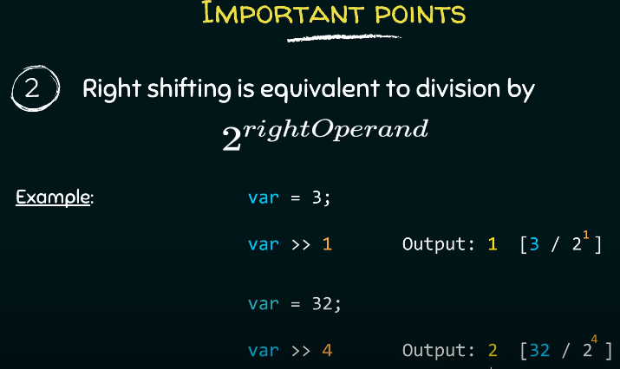

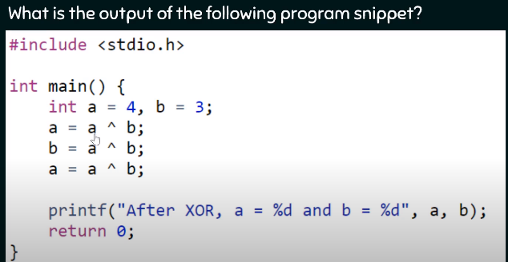

**Questions on Bit-wise operators:**

**Question 1:** Check if a given number is a power of 2.

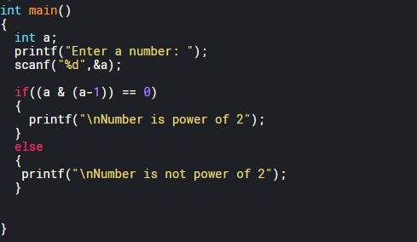

**Question 2:** Check what power of 2 is the number?

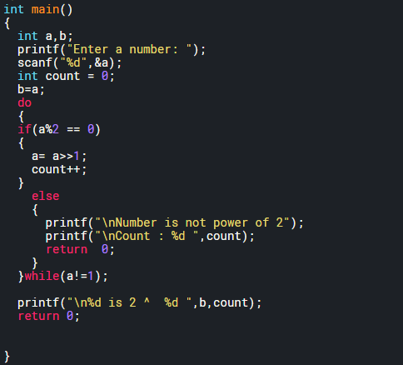

**Question 3:** Count the number of ones in the decimal.

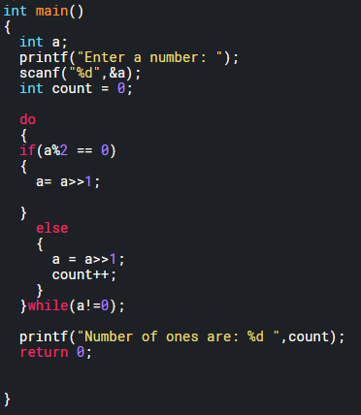

**Question 4:** Check if the i-th bit is set.

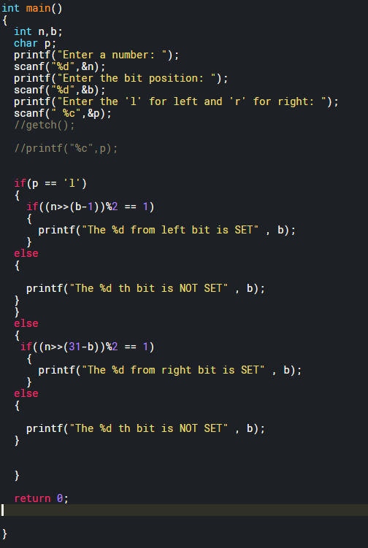

**Assignment Operators:** used to assign value to a variable.

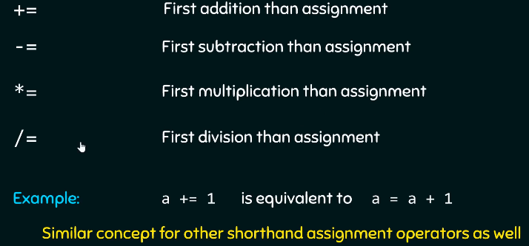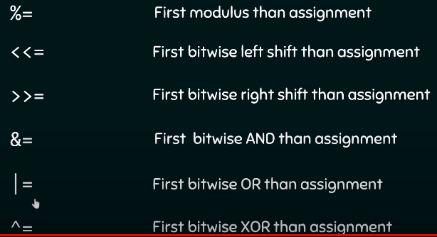

**Conditional Operators:** used to assign value to a variable.

* ? :

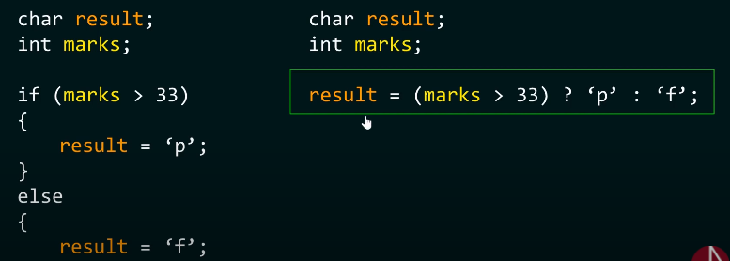

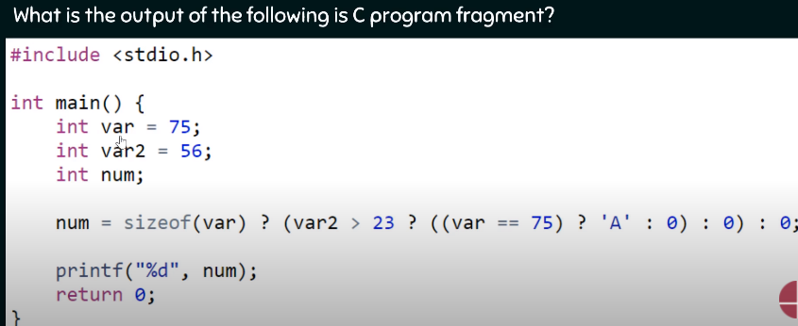

Answer: 65

**Comma Operators:** used to assign value to a variable.

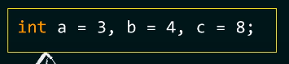 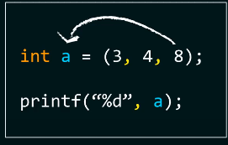

1. Comma operator will evaluate all the values but assign the right most one.
2. Below it will print HELLO and then assign VAR = 5 and later print it on screen.

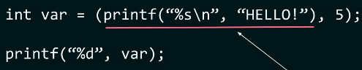

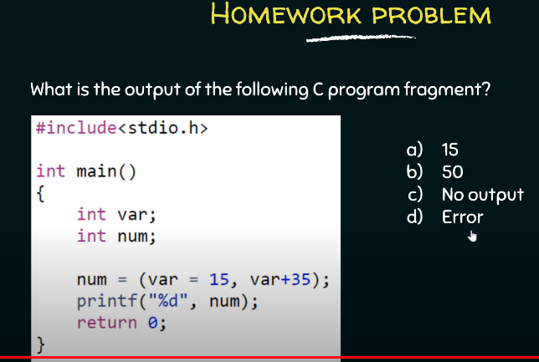Answer: **Very Important**: 50

**Precedence and Associativity of Operators:**

1. Higher precedence operator will be given priority.

**Associativity:** Associativity comes in the picture when precedence of the operators is same.

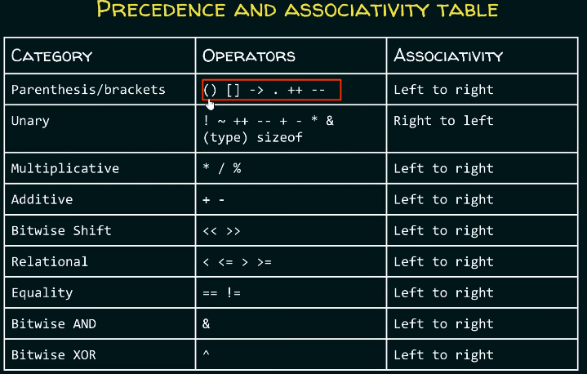

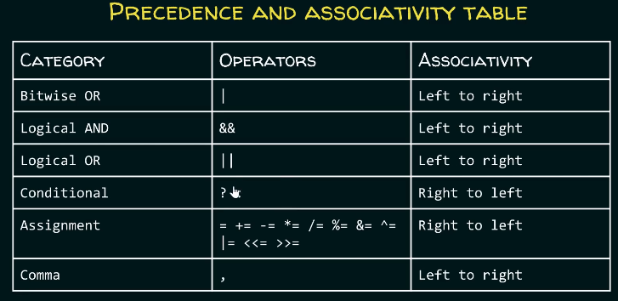

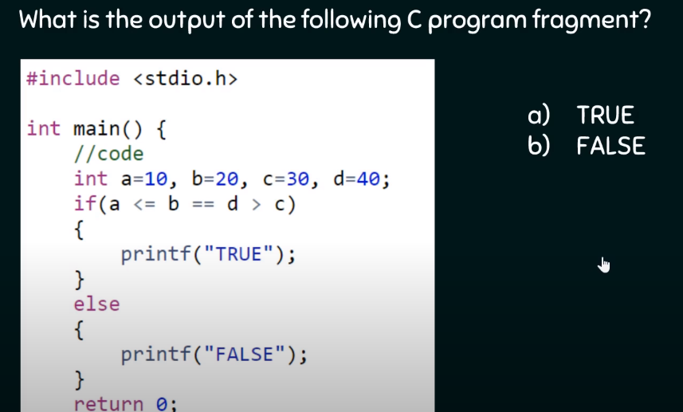

**Ans: TRUE**

**Questions:**

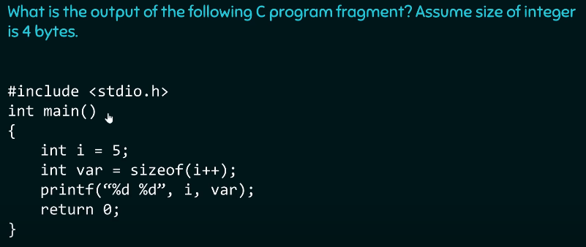

Answer: is 54 not 64. Because according to C99 standard(not C11), sizeof(i++) will give size of variable type and will only solve the expression when it’s a variable array type.

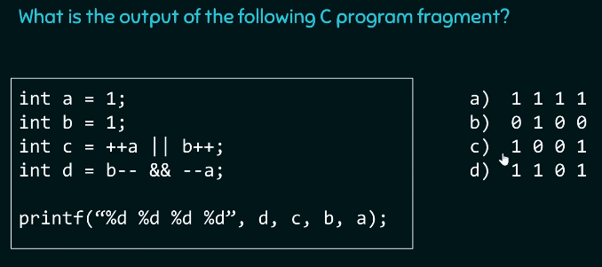

Answer: **Very Important,** work again

**Rapid Fire:**

Go back to Video 37 and do the quiz.

**Conditionals:**

**If else:**

**Switch:** Good replacement to long if else constructs

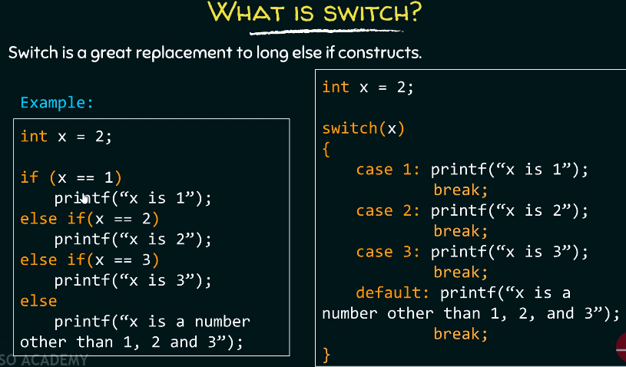

1. Why put break? If you don’t put break, then substituent functions will be evaluated **once the condition is satisfied** until we reach the **break**.
2. Conditions of switch: You aren’t allowed to duplicate cases.

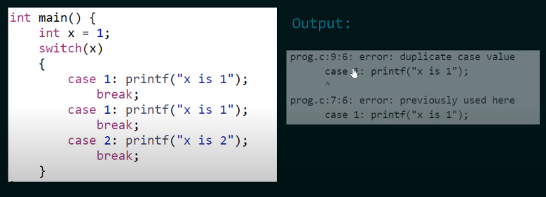

1. Only those expressions are allowed those are integral **constant values** in switch statement. **No floats** allowed.

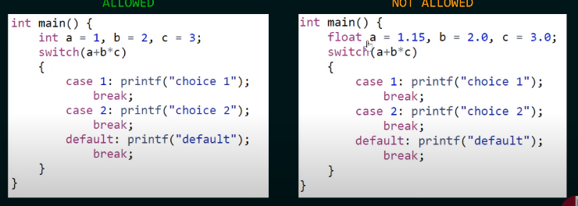

1. **Floats are not allowed in the CASE statement either**. However, **expressions** are allowed that will lead to integer value.

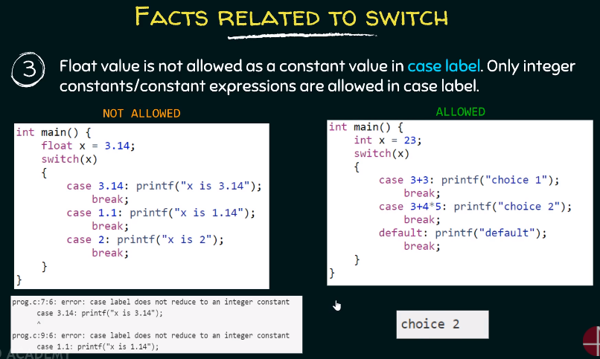

1. **Variable expressions aren’t allowed.** However, **macros** are allowed. Also, Integer.

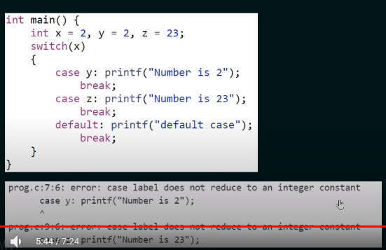 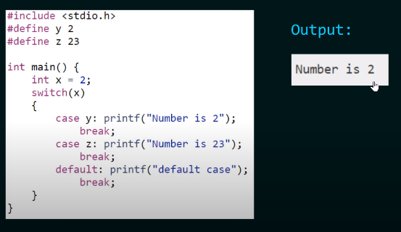

1. **Default** can be put anywhere. And will only be evaluated once all the cases are evaluated.

**For while loop:**

**While loop:**

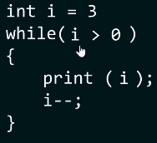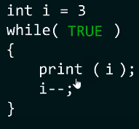

**For loop:**

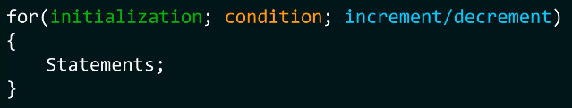

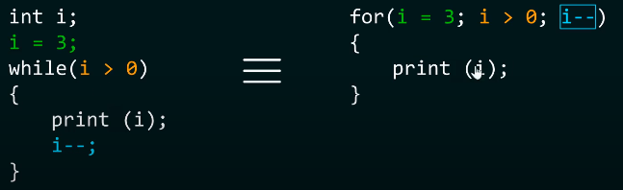

**Do while loop:** Evaluate the arguments and then check the condition. Unlike while, where you check the condition first and then evaluate argument.

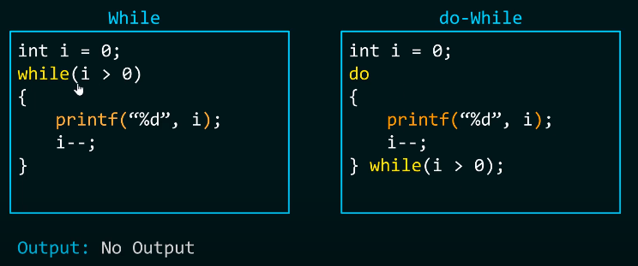

1. Write a program that allows user to enter a value, until he or she enters zero. Using while and do while genius.

**Break and continue:**

**Difference between Break and Continue: Break** the loop and **Skip** the loop.

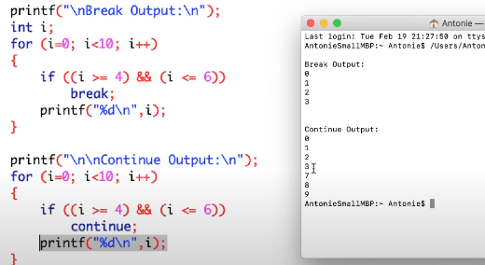

**Questions:**

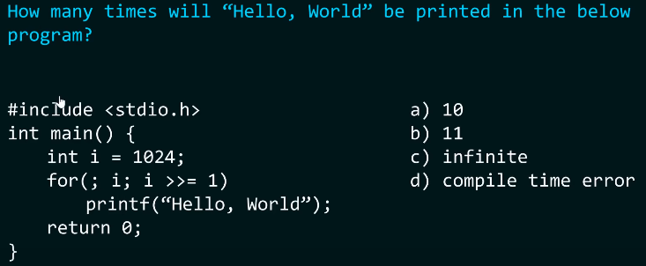

Answer: 11

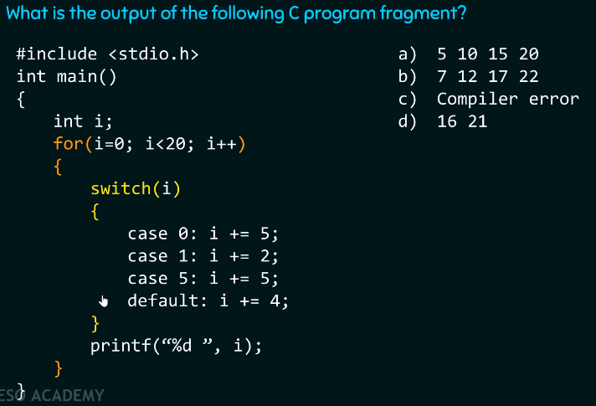

Answer: Do it on your own.

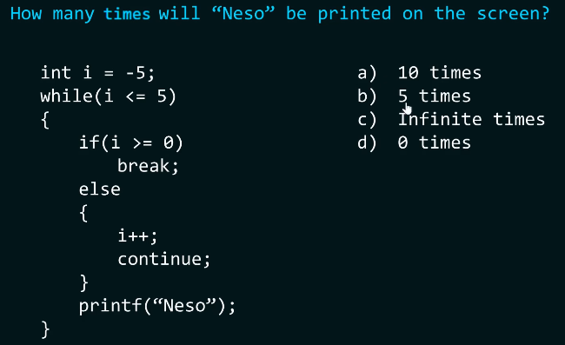

Answer: Do it on your own

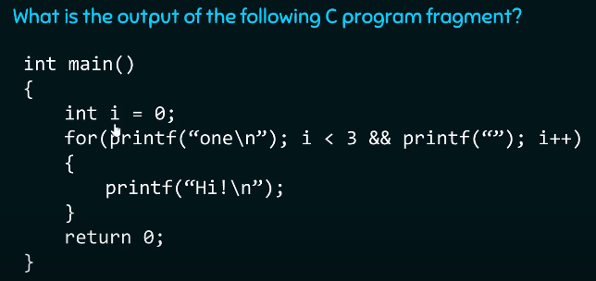

Answer: **Very Important Question.** Do it again.

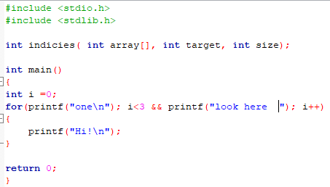 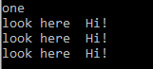

Also, look. ONE is only printed once.

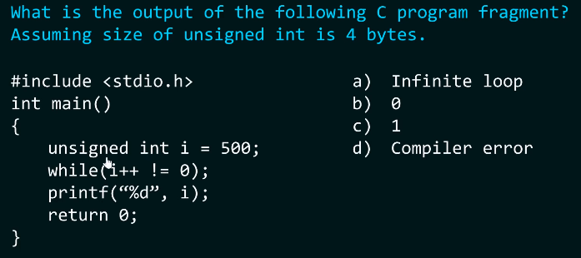

Ans: Do it again.

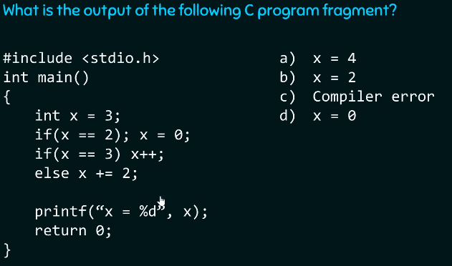

Answer: Do it again

**Pyramid of Stars Palindrome Armstrong**

**Function:**

Why functions?

* Reusability and abstraction

Function declaration as a prototype:

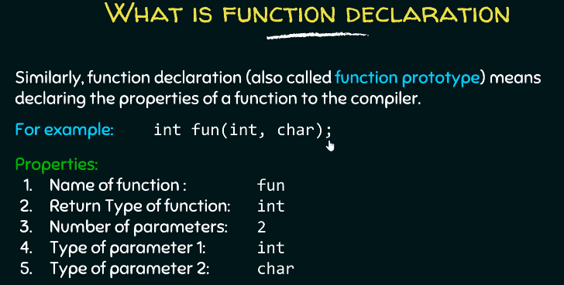

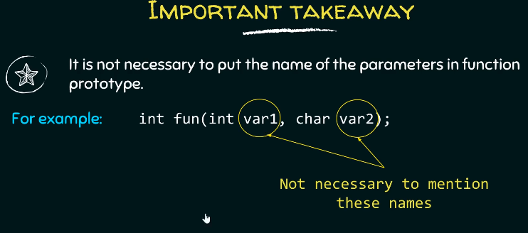

* Is it always necessary to **declare** a function before using it? No. You **do not** have to **declare**. Instead of declaration you can define the function too before the main function.
* What happens when you do not declare or define a function? Implicit declaration

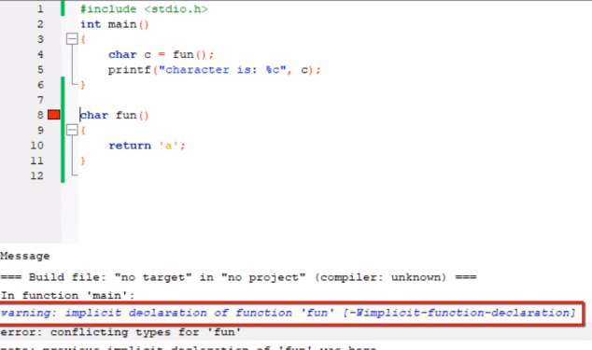

* Two errors: Conflicting types for “fun” and Implicit declaration of function.
* **Conflicting types Error:** Since the function is not declared or defined, therefore, complier assumes the return type of the function to be integer data type.
* **Implicit declaration warning**: Compiler implicitly assumed return type to be integer.
* If you declare an integer type than you can bypass function call and declaration.

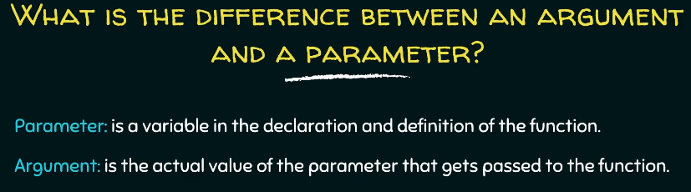

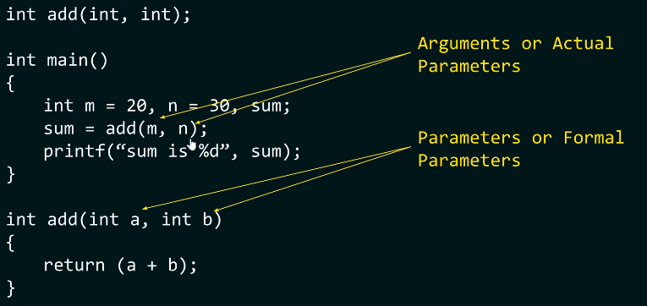

**Call by value and call by reference: With example!**

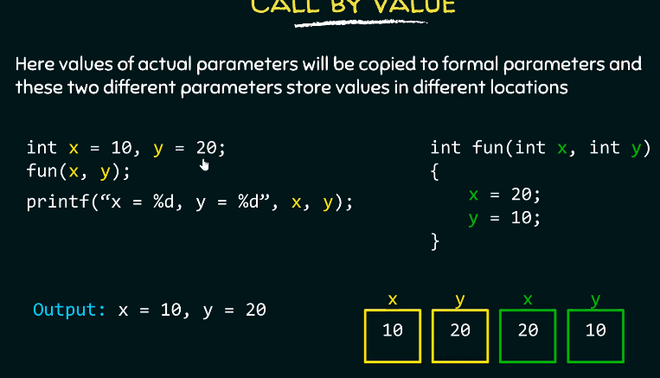

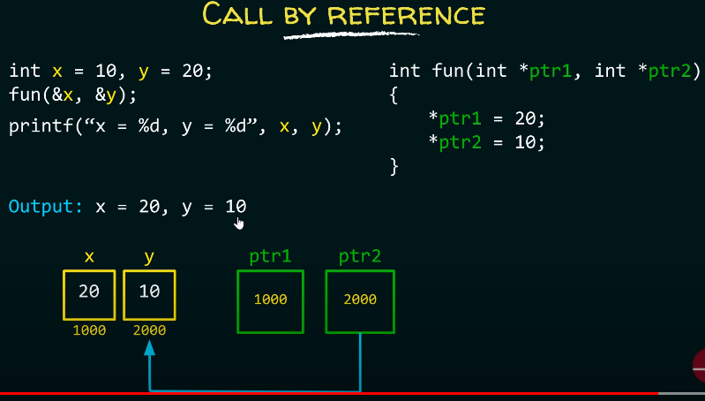

**Questions:**

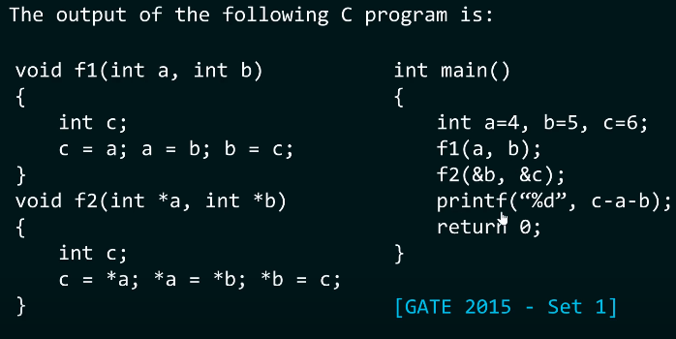

**Answer:** -5

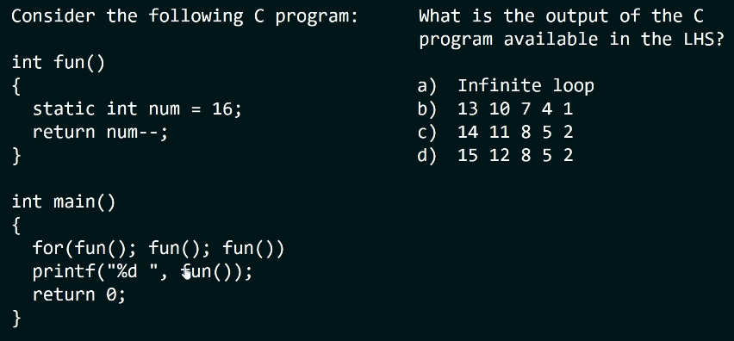

**Answer:** Very important. Do it again.

**Static Function:**

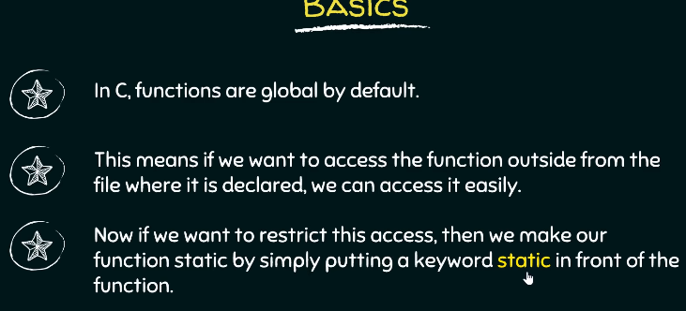

**Static scoping and dynamic scoping in C:**

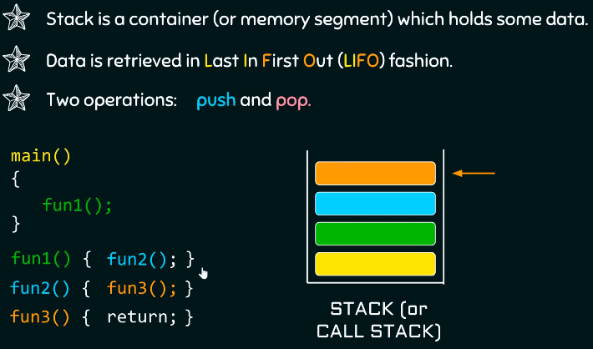 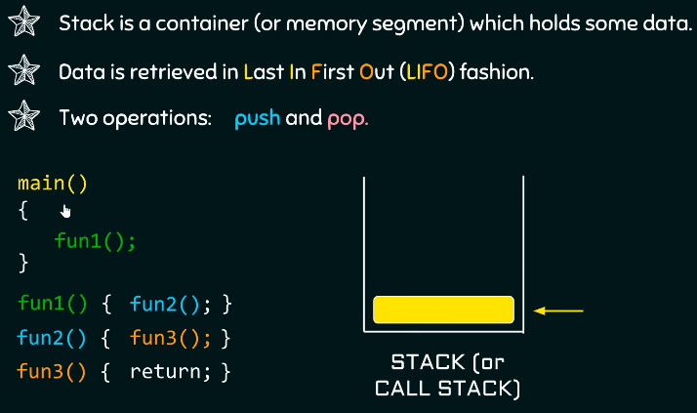

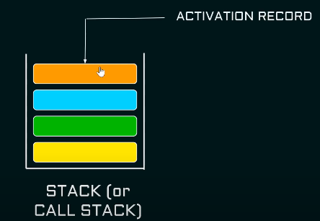 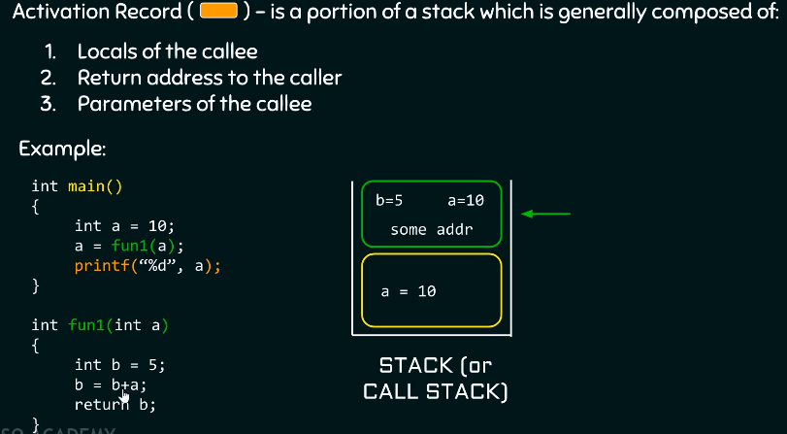

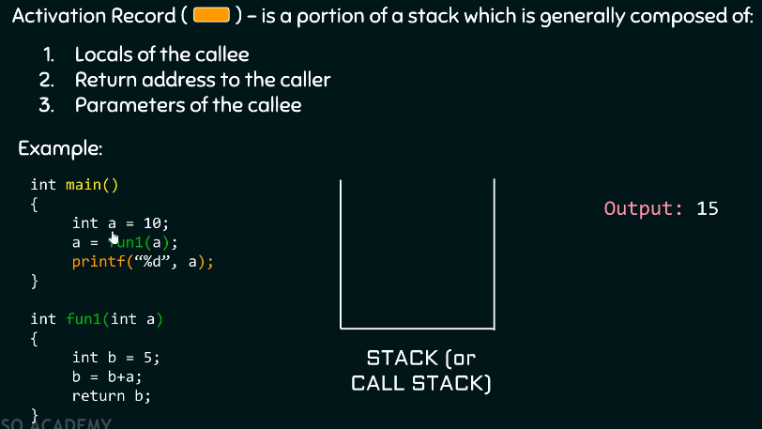

**Scoping:**

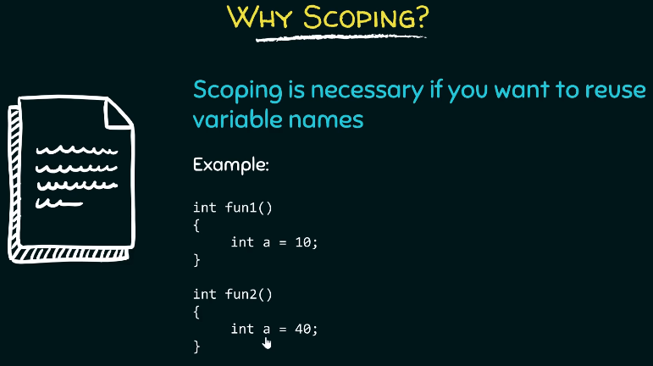

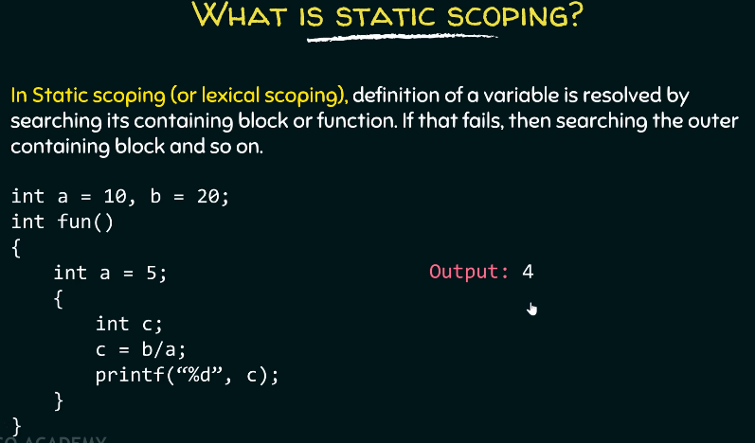 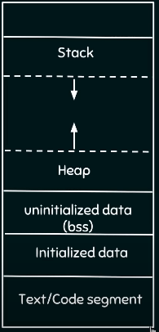

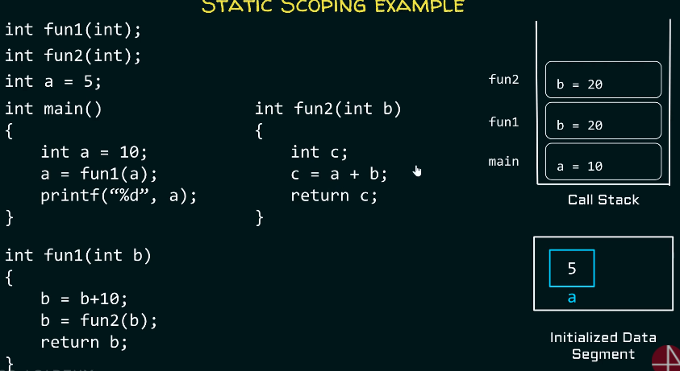

**Dynamic scoping:**

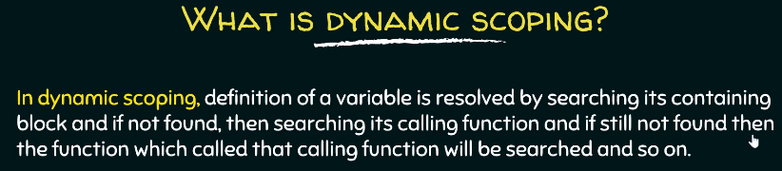

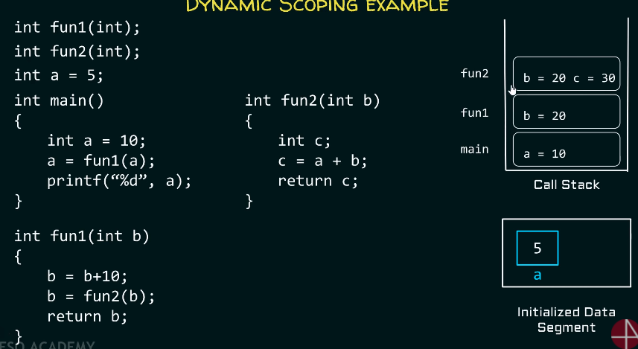

**Recursion:**

1. **Recursion: Function** calling **itself.**
2. **How to write a recursive function:**
3. **If – else** construct
4. **If (base):** return **1**; **terminate** the **recursion**.
5. **Else :** return the function itself.

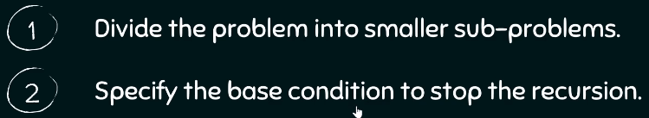

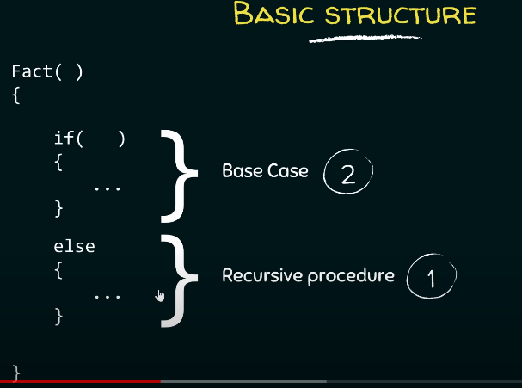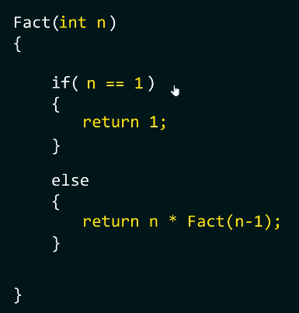

1. How to find **recursive procedure**: Look at the picture below.

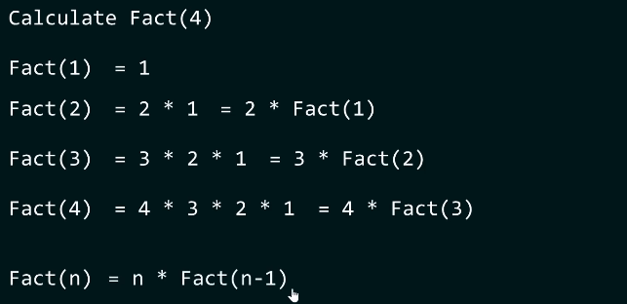

1. How to find the **base condition:** Condition which doesn’t require to call the same **function again.**

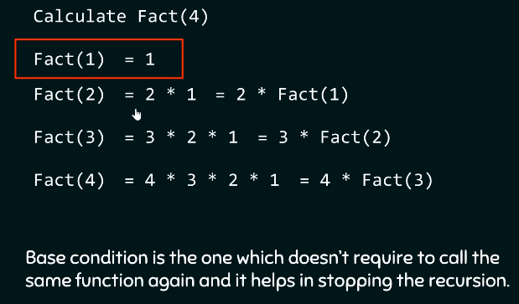

1. **Types of recursion:**

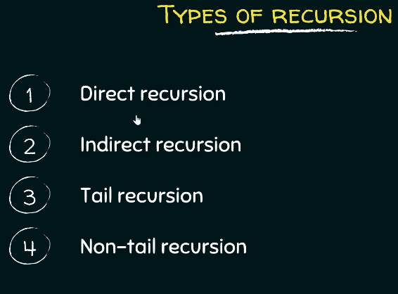

1. **Direct recursion:**

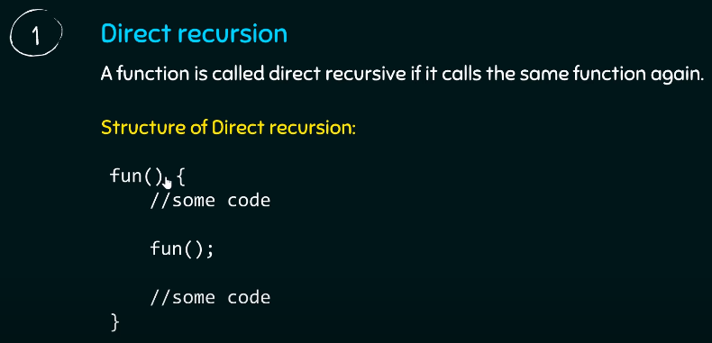

1. **Indirect recursion:**

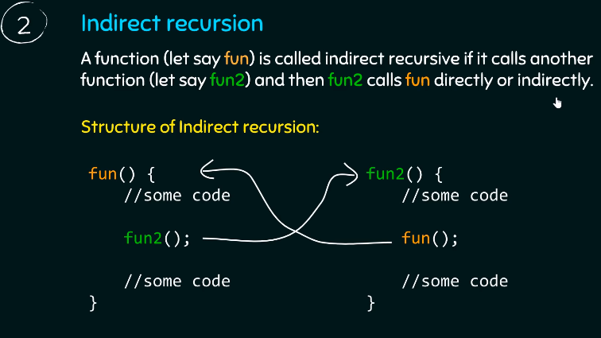

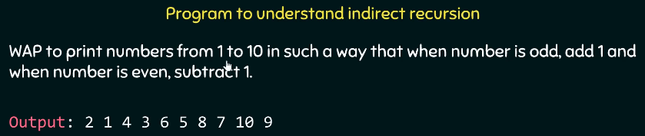

1. **Tail recursion:**

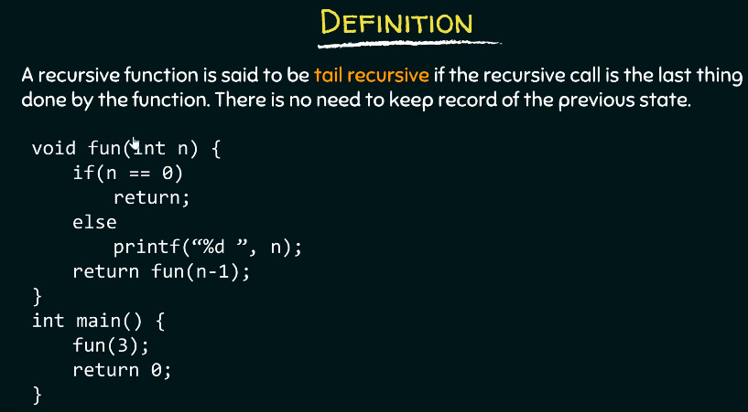

1. **Non tail recursive:**

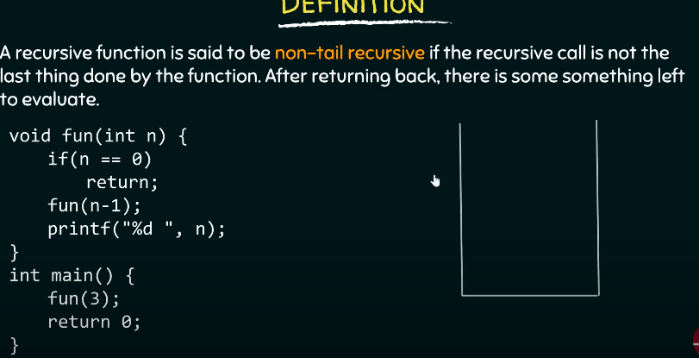

1. **Iterative program vs recursive program:**
2. **Sometimes iterative code is** too complex to write, hence recursion.
3. **Questions on recursion:**
4. Write a **recursive program** to find **sum** from **1 to n**:

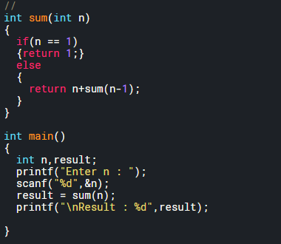

1. **Print** the **array** using **recursion:**

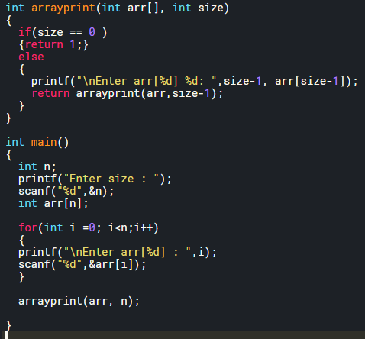

**Array 1-D:**

**What is Array:** Array is a **data structure** that contains **values of same type**.

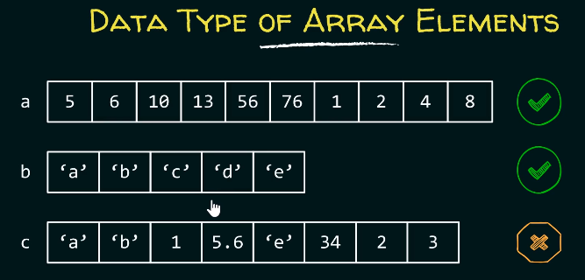

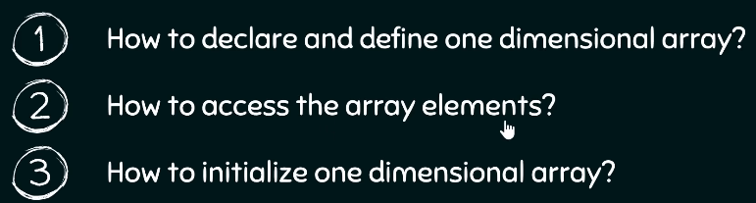

1. **Declaring an array:**

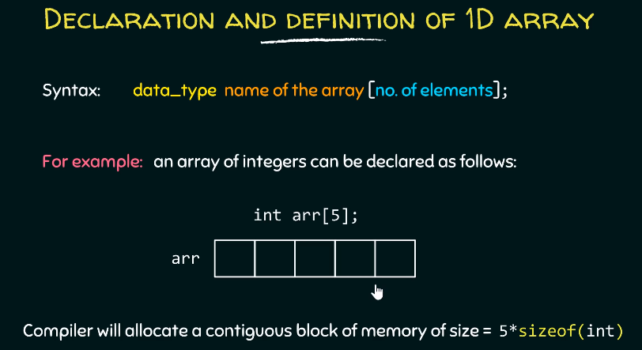

1. **Declaring size of an array:** Can be declared using a **positive** **constant value** or a **constant expression**.

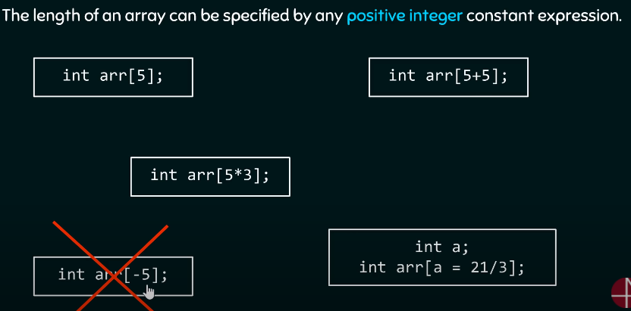

1. **How to define 1-D array:** In method 2, size is defined by the compiler since you’ve initialized the array already. You can’t create an array without specifying the size of it.

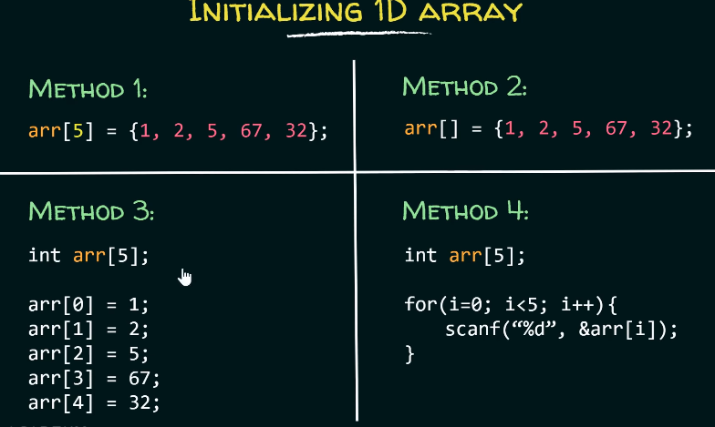

1. **Initializing the values in array:**
2. **By default**, the **value** of an **array** is initialized to **garbage**.
3. **Partial initializing** leads to reset of the elements being filled as **0s**.
4. **To initialize to all zeros,** leave the curly bracket empty.

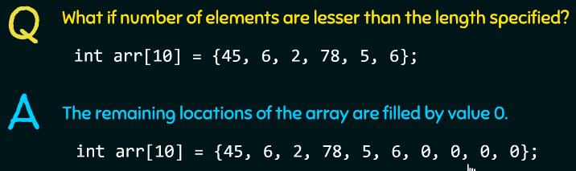

1. **What** to if we want something **like below?**

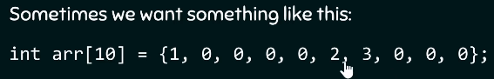

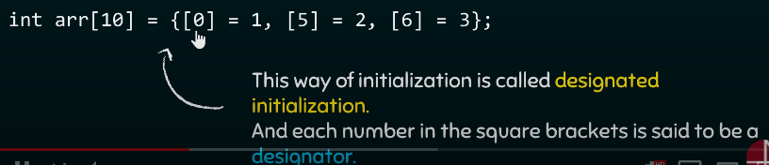

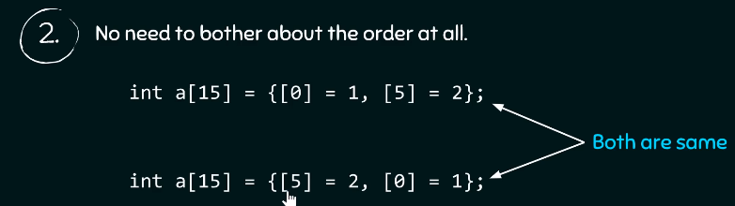

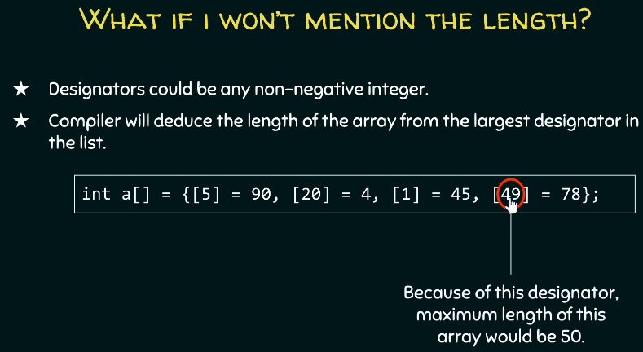

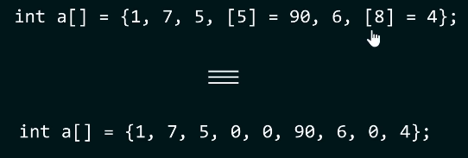

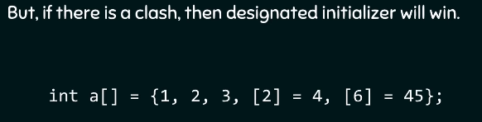

**Questions on Array 1-D:**

**Question 1:** Find the number of elements in an array.

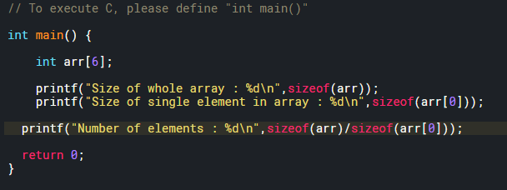

**Question 2: Traversing** through an array of limit size. Take user input from the user and fill those elements and then print them. Then change it to character array and float array.

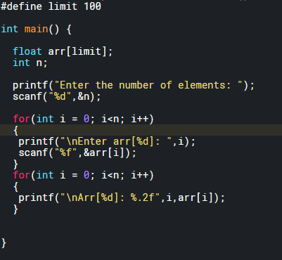

**Question 2: Insertion** in an **Array**.

1. **Rules for insertion:**

* Array[limit-1] = array[limit-2] ; limit—
* Till **position +1;**
* Insert new value at **position-1**

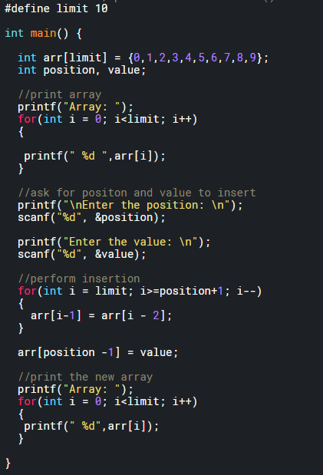

**Question 3: Deletion** in an **Array**.

1. **Rules for Deletion:**

* Array[position-1] = array[position]; position++
* Till **limit;**

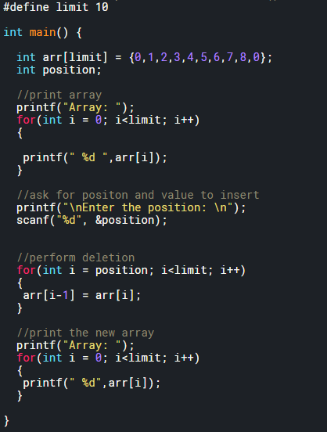

**Question 3: Reverse** the elements in an **Array**. Then reverse **first half of an array**.

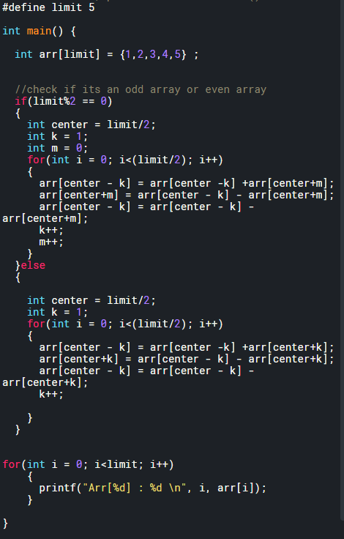

**Question 4: Convert decimal to binary** then store it in an array.

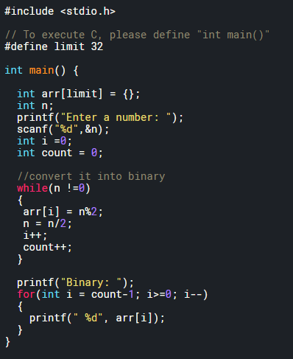

**Question 4: Print odd and even number** separately.

**Question 5: 2nd largest element in array.**

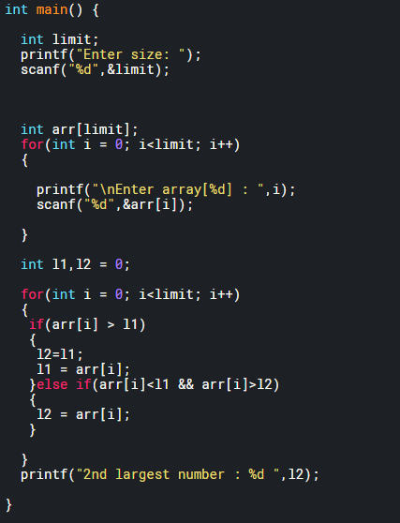

**Question 6:** How many times **each element repeats itself in the array**.

**Multi-dimensional Arrays: 2-D and 3-D:**

1. **What is a 2D array?** It is an array of array. Ex: **arr[2][3] = 6** elements in total.
2. **Declaration:** datatype name [x][y]. **X** here being number of **rows** and **Y** being number of **columns**.  **YOU HAVE TO DECLARE THE SIZE.**
3. **How to visualize a 2D array?** Here is a 2D array. Basically, think of it as 4 -1D arrays stacked on top of each other.

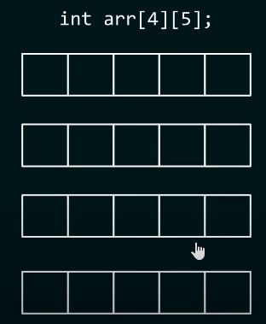

1. How to initialize a 2D array? Initialize them like you will **initialize a normal 1-D array.**



1. How is a 2D array filled? Think logically. **Left to right** and then **top to bottom.**

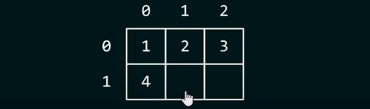

1. But the last way is confusing. Let’s see a better way of initializing a 2D array.

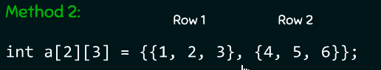

1. How is an array filled in this way? **Same as last time.**
2. How to **access each element** of a 2D array: **arr[0][1].**
3. Print each element of a 2-D array:

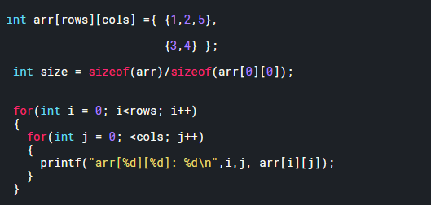

1. Multiply two matrices and store the result in the third one:

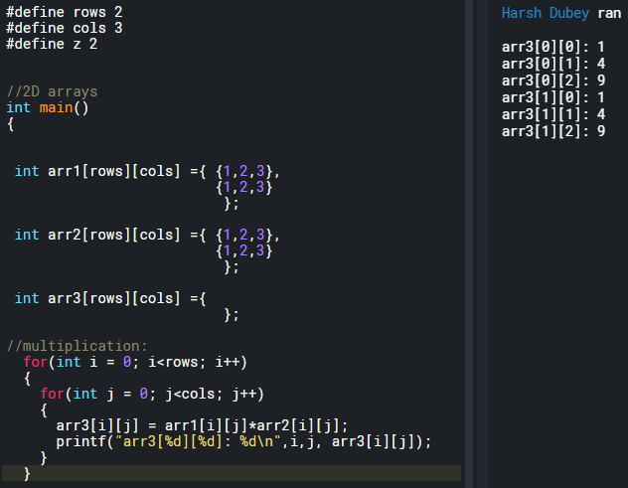

1. 3-D array: Basically arr[z][rows][cols]: z denotes number of 2-D arrays.
2. How to store an element in a 3-D array and then print it.

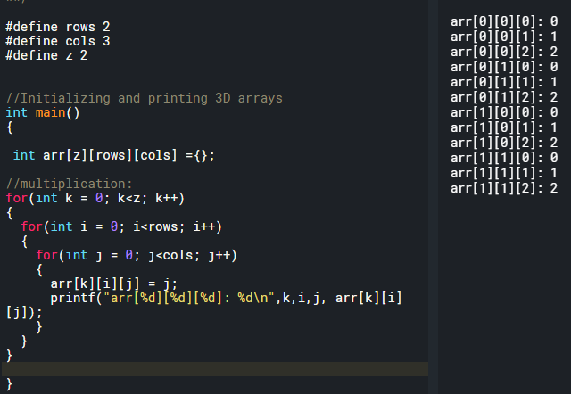

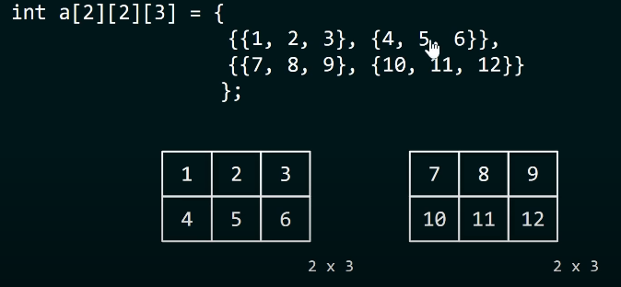

1. **Questions** on multi-dimensional arrays: **REMEMBER CRRC**
2. Write a program that will print sum of rows and cols in a 5x5 array.
3. Matrix multiplication: Size of the resultant matrix is:

* **m1[rows][cols] x m2[rows][cols] =** Matrix [**rows of m1**] [**cols of m2**].
* How to multiply? Rows x Cols. Then add all of them. Shown below.

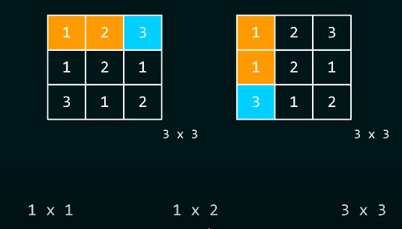

1. **Rules** for **matrix multiplication: CRRC**

* Cols of 1st = rows of 2nd must be equal.
* **m1[rows][cols] x m2[rows][cols] =** Matrix [**rows of m1**] [**cols of m2**].
* **Matrix [0][0] =** Sum (m1 row0 x m2 col0)

1. Write a program that multiplies two matrices:

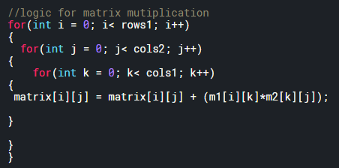

**Constant arrays and variable length arrays:**

1. **What’s a constant array:** Look up table!! **Read-only table**. Remember from EE347. For sensor calibration.
2. **Why is it called const?** BC once initialized, then it can’t be changed. Ex, below.

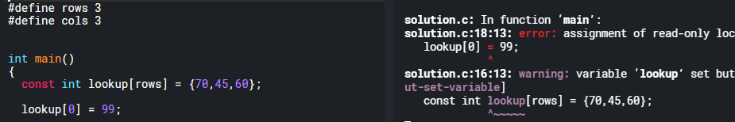

1. **Look-up table** can be **1D or 2D.**

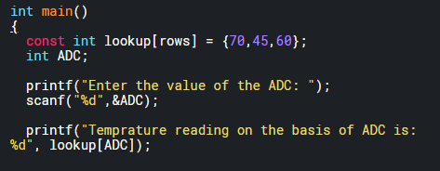

1. **Variable length array:** Length of the array is specified during the runtime.
2. **Variable length** arrays **can’t** **be initialized** and **declared** at the **same time.**
3. Size can be given in terms of an expression.

**Pointers:**

1. **What are pointers? Address**, pointers are **ADDRESS also called REFERENCE**. Don’t think of them as anything else.
2. What happens when you **pass in a pointer?** You pass the **address.**
3. What happens when you **return a pointer?** You return the **address.**
4. Remember: Referencing: **&address** and dereferencing: **\* Value.**
5. **Declaring and initializing pointers:**
6. **Declaring a pointer:** Specify which data type will it point to. Ex: char*ptr will point to character and int*ptr will point to an integer.
7. **Defining a pointer:** Specify which address will it point to. **int* ptr = &x**. Look, we have assigned the **address of x** to ptr.
8. **What if try to assign the address of an integer to a char pointer?** We can. And if we dereference it then it will print the 1st byte of it. However, it will show a warning.

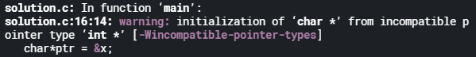

To fix this. Just type cast the pointer into character pointer.

1. **What if a float pointer is assigned to an integer pointer:** Will print 0.000000 even though the addressing is incremented by 4 bytes?
2. **What if a double pointer is assigned to an integer pointer:** Segmentation fault. But not in case of an integer array where 8 or more than 8 bytes of data is available.

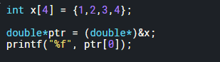

1. Can we create a pointer to unsigned values? Since the purpose of
2. **Value of operator or dereferencing operator:**
3. When you print the pointer, you print the address of the variable the pointer points to.
4. To get the value we have to de-reference a pointer using * operation.

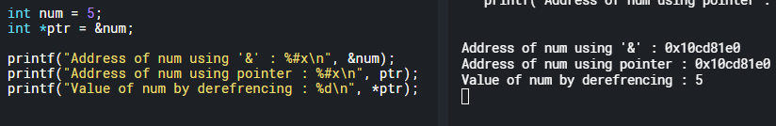

1. **Caution:** Do **not dereference** a **pointer** that is **not** been **initialized** i.e., **a wild pointer.**
2. What will happen if we **dereference a wild pointer**? **Segmentation fault.** Wild pointer may point to a memory location, but we don’t have a legal right to access that memory location. Hence **segmentation fault.**
3. What is **segmentation fault: Program** trying to **illegally read or write** to a **memory location.**
4. **Pointer assignment:**
5. **Address assignment:** When you assign one pointer to another then you are assigning the content of one pointer to another i.e., the address. Look at the example below to understand it better.

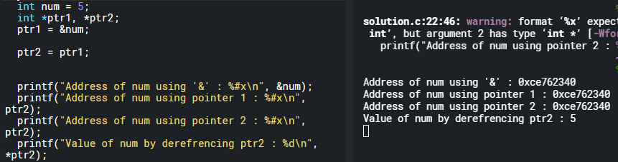

1. **We can also assign the value of one pointer:** ptr2 = *ptr1, by dereferencing it.
2. **Question:** Just by reading.

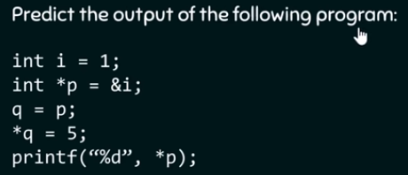

1. **Pointers and functions (Pass by value and pass by reference):** Write a function that uses pointers to find the min and max value of the array and returns the value.
2. **Pass by value vs pass by reference:** Why pass by reference? You can’t return two values in C from a function.

* **Pass by value:** You pass in the value of the variables and do computation and come back. **You do not change the value of the variable.**

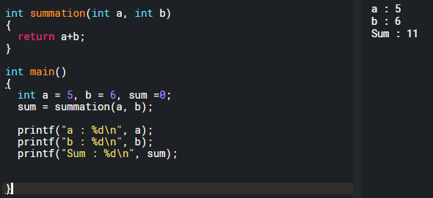

* **Pass by reference:** You pass in the address of variables. Do computation and return the sum.

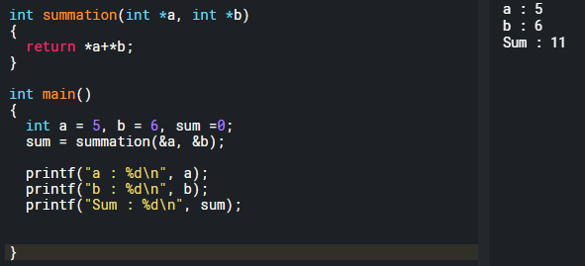

* **Difference between pass by value and pass by reference:** In pass by reference, you can actually change the content of the register.

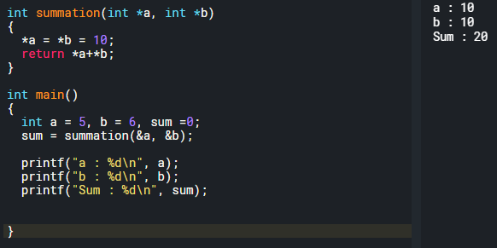

* **Why else use pass by reference?** Try returning 2 values from a function.

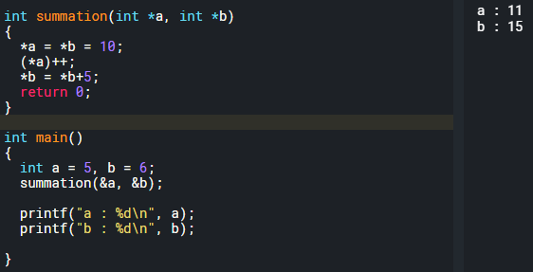

1. **Another example of changing values by passing them by reference:**

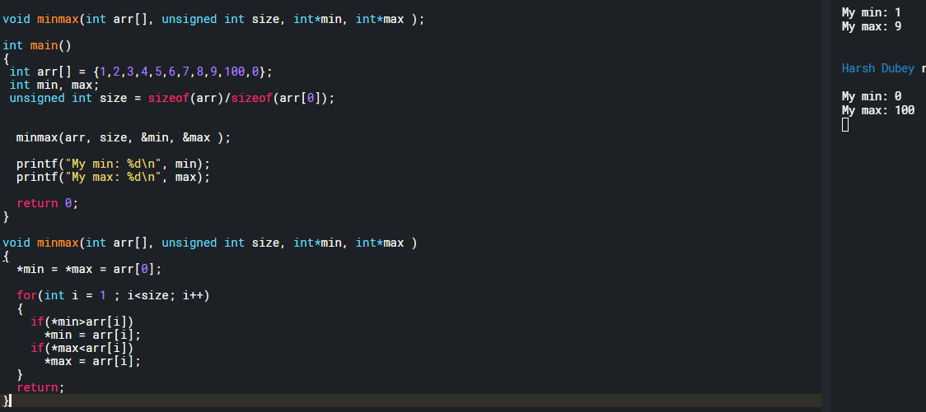

1. **Accepting and Returning pointers from function:** Return the pointer to the midpoint of an array then change the 1st byte of it for an integer.
2. **Accepting:** Accepting a pointer means accepting the address

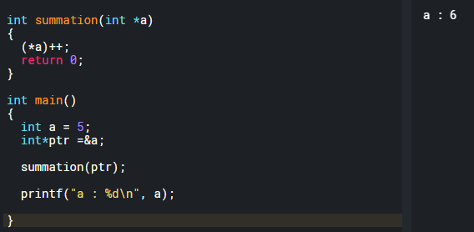

1. **Receiving a pointer:**

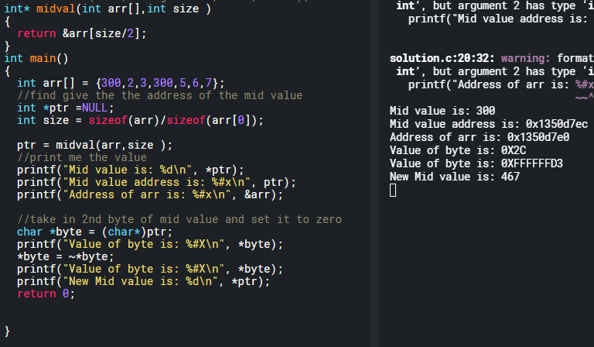

1. Redo this using **float and double precision. Print out mantissa, exponential and sign bit.**  For float: 4.25. And the figure out the **endianness of the system**.
2. **Big endian: MSByte** in the **smallest address.**
3. **Little endian: LSByte** in the **smallest address.**

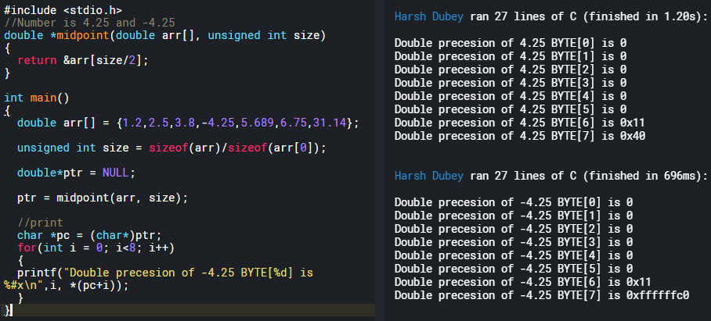

1. **Convert floating point into binary:**

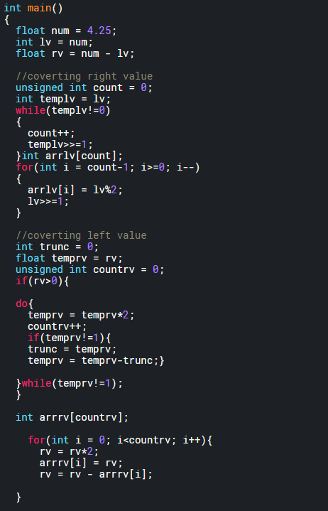

1. **Questions on pointers:**

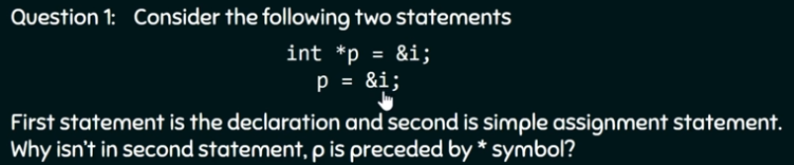

**Answer:**

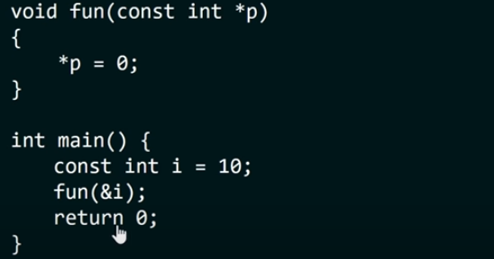

**Answer: Error.** Assignment to read only location.

1. **Pointer arithmetic:**
2. **Adding integers to pointer:**

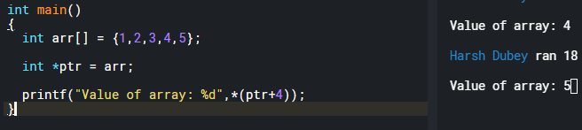

1. **Post increment and pre-increment:**

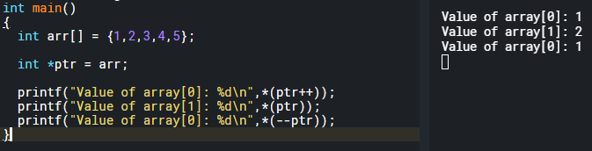

1. **Comparing the pointers:** Only possible if both pointers point to the same array? No.
2. **Find the sum of the elements of an array using pointers:**

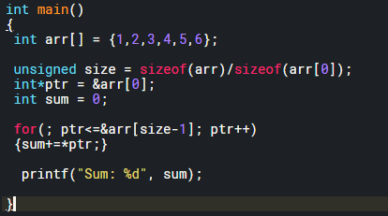

1. **Arrays and pointers: Array’s name** is just a **pointer** to the **first element of the array**.
2. **Referencing** and **dereferencing** array name**: arr[1] = *(arr + 1)**
3. **Note:** we can’t assign a new address to the pointer pointing to the base of an array.

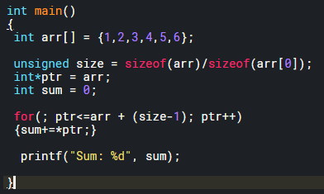

1. **Passing array as an argument to a function:**

* When we pass an array to function, **we are not passing the whole array,** we are **passing the base address** of the array.
* **Question:** why when we pass a variable to function, we don’t change its value but when we pass an array, we change its value. Let us see an example: **BC when we pass in array, we pass in base address of the array.**

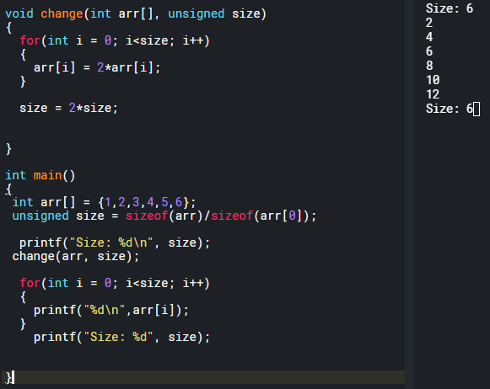

* **Can we pass array elements as values to the function: Yes,** it will behave exactly as pass by value? Look at the example below.

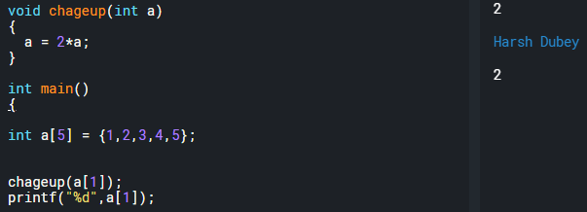

1. **Pointers to 2D arrays: Row major** order vs **column major** order. **C stores** **multidimensional** arrays in **Row major order**.

* What is **row major order:** It is a **convention** that **C uses to store multidimensional** arrays.

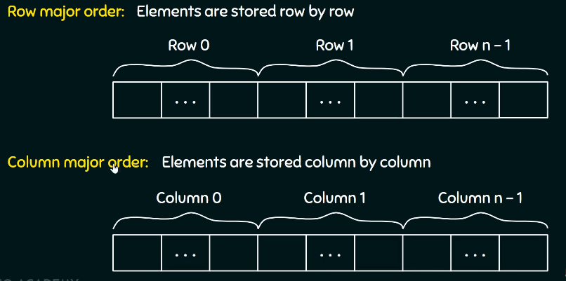

* **Reassign the values of a 2D array and then print them by using a single for loop:** We can use pointers and exploit the row major order and access the elements of a 2D array in 1D fashion.

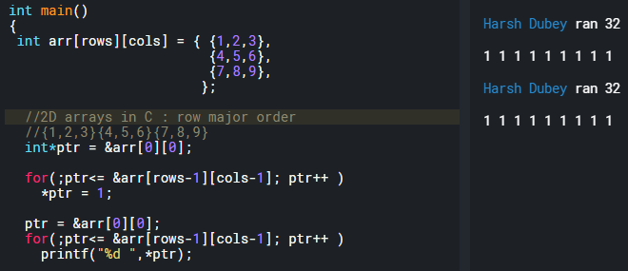

* **Then investigate 3D arrays using pointers:** Even 3D array follows row major order.

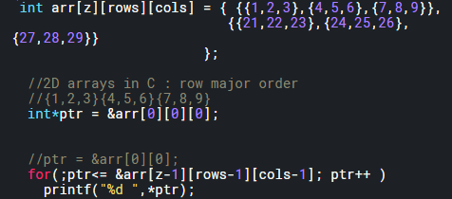

* **Caveat:** Look at the code above and see every time we use **pointers, we** **initialize** it with the **starting address of the first element of the 2D array**. But why? **Can’t we initialize it with just the array name?** Since, that also contains the address of the first element of the array. Explore.
* **Ask yourself what makes a 2D array a 2D array?** Or a **3D arrays a 3D array?** Aren’t they in memory stored the same way a 1D array is? You **add pointers** to **add dimensions!!**

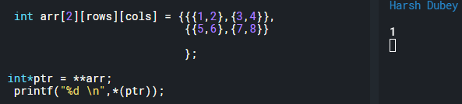

1. **Questions on arrays and pointers:**

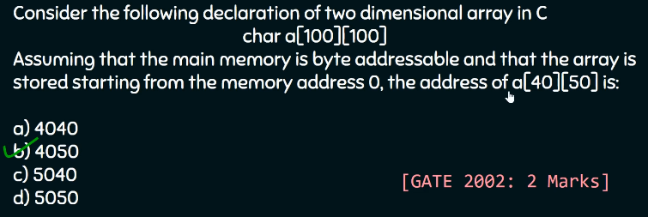

**Careful.** This could be an integer array too.



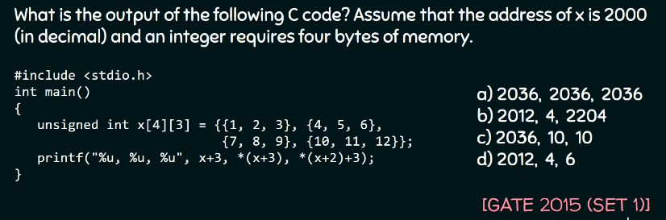

**VERY** important.

1. **Pointer to an entire array:**
2. **Array name and pointer to an array: Array name** is the **pointer** to the **1st element**. Example with memory layout. However, **it’s a self-pointer.** The if we create a **pointer to the array,** and it’s not a self-pointer, as shown below.

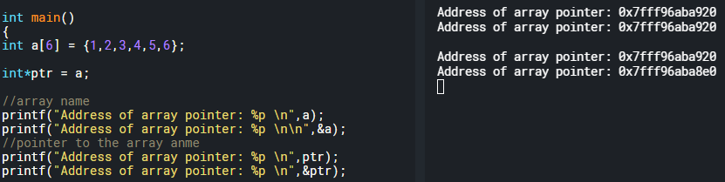

|  |  |  |
| --- | --- | --- |
| 106 | 6 |  |
| 105 | 5 |  |
| 104 | 4 |  |
| 103 | 3 |  |
| 102 | 2 |  |
| 101 | 1 |  |
|  |  |  |
| Breakage |  |  |
| 101 | 101 | **a** |
| 51 | 101 | *p |
|  |  |  |

1. **Let’s analyze the 8 results:**

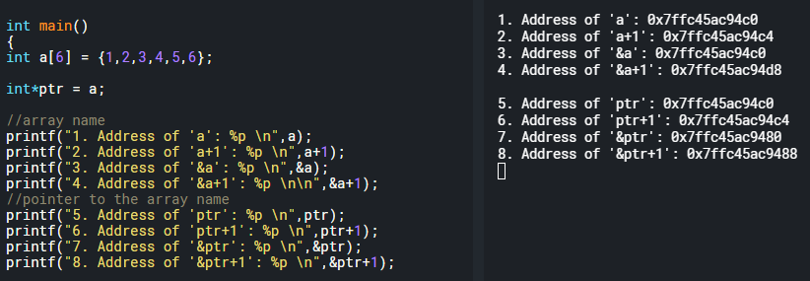

1. **‘a’** i.e. array name, is an integer pointer to the 1st element of the integer array. So, ‘a+1’ will be address of a + 4 bytes.
2. **‘a+1’** is address of a+ 4 bytes.
3. **Address of ‘&a’ is same as ‘a’:** Self pointer. However, they differ in property.
4. **‘&a’** when incremented with ‘+1’ it increments with **24 bytes.** Because **‘a’** is a **integer pointer** and **‘&a’** is a **(*)[size] pointer.** We will analyze a **(*)[size] pointer later.**
5. **‘ptr’ contains the value of ‘a’.** Which is the **address of the 1st element.**
6. Just like **‘a’, ‘ptr’** is an **integer pointer. Hence, incremented by one byte.**
7. Address of **‘ptr’,** in this case **it’s not a self-pointer** hence different address than content of ‘ptr’.
8. **IMPORTANT.** To the **address of any pointer, if added 1**, will **move 8 bytes** if it’s **a 64 bits machine**. Hence, pointers are very useful when it comes to knowing the machine.
9. **(*)[size] pointers:**  Create a **Double Pointer** to whatever it points to**.** Image below will prove that.

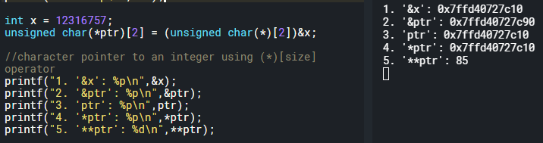

1. **‘&x’** will give the address of x.
2. **‘&ptr’** will give address of ptr.
3. **Address** of **‘&ptr’** and **content** of **‘ptr’** is **different. IMPORTANT.**
4. **‘*ptr’ != ‘ptr’,** NOT EQUAL. Even though the address is same, but behavior is different.
5. **You dereference** again and you get the value stored in the memory.
6. **(*)[size] pointers in case of array name:**  In case of array name, (*)[size] pointer is **a self-pointer**. Look above, everything is same, except **C.** Address of ‘&arr’ will be equal to the content of ‘arr’. Example, below.

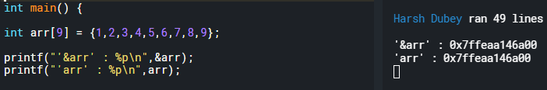

1. **Make a 1D array into a 2D array:**

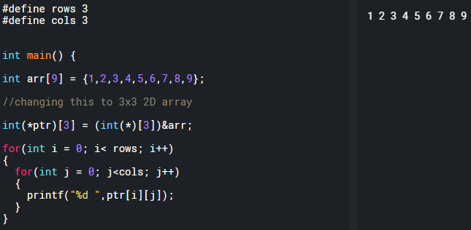

1. **Size of pointer to array:**
2. **Sizeof():** returns **long unsigned int** or **size_t.** Run the statement below and you’ll get answer as 8 bytes. Because it returns **size_t** and that’s an **unsigned long integer**.

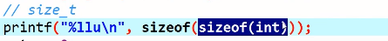

1. **Let’s investigate array pointer and size of operator:** Below program is very important, I’ll explain it in the next bullet point.

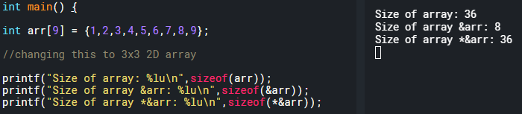

1. **Dereferencing the pointer below shows the true size of the pointer:**

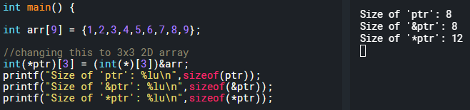

1. **Array subscript operator:** Why is 4. Working? Because **addition is commutative.** **\*(arr+1) = *(1+arr)**

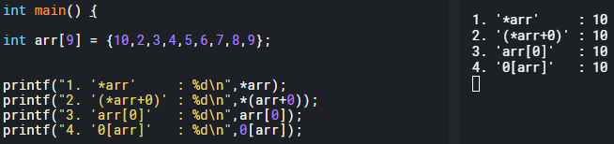

1. **Kinds of pointer:**
2. **Void pointer: Property less** pointer. There is **no referencing property** and **no dereferencing property**. You must **type cast a property to it** before referencing or dereferencing.

**As shown below,** referencing property of void pointer is to refer memory byte by byte.

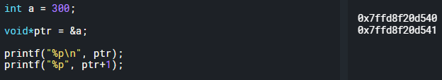

**However,** you can’t **de-refer** it.

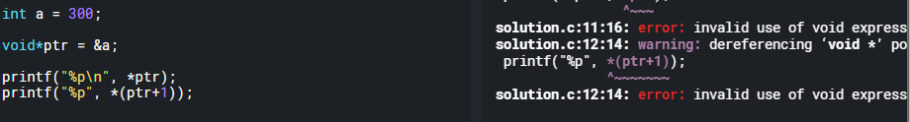

Why use **void pointer?** That’s what malloc returns.

1. **Null pointers: Doesn’t point** to any **memory location** or **points to** an **invalid memory location. NULL** in case of pointers is 0. Don’t confuse it with the integer 0.

We can assign a pointer to NULL, to be safe.

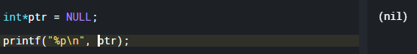

Why you use NULL? BC that’s what malloc returns.

1. **Dangling pointers: Pointer** that **points** to a **non-existing memory location**.

**In this example,** we have a pointer and we allocated memory and *ptr has the memory address of the 1st byte. Then we free the memory and *ptr becomes a dangling pointer because it still points to an invalid memory location.

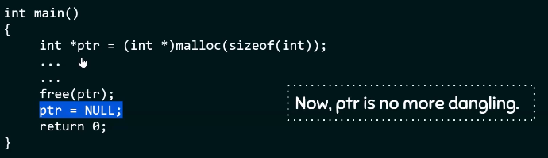

**In this example,** we have is automatic deallocation of memory. Remember automatic variable, they get automatically destroyed. Hence, the pointer becomes a dangling pointer.

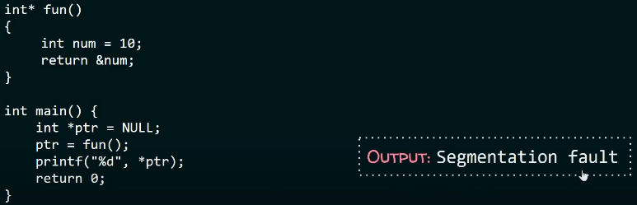

1. **Wild pointers: No address** assigned to the **pointer.**

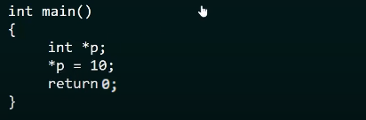

1. **Memory manipulations using pointers and arrays: #include<string.h>**
2. **Memcmp():** It compares memory. How does it compare memory? **Byte by byte**. The result of comparison is the %ld. **Int x = memcmp( a, b, sizeof(a));**
3. **If (x == 0):** Arrays are same.
4. **If(x > 0): a[] > b[]**
5. **If(x < 0): a[]<b[]**

The third parameter is **sizeof(), takes in the number of bytes to be compared. Then compare BYTE BY BYTE.** Lower order BYTE 1st.

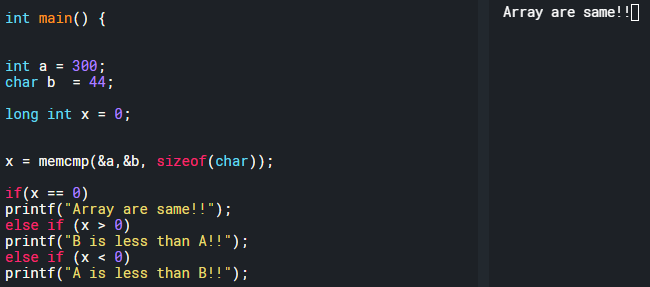

That means given any kind of data set, we can compare it and see what’s missing and what’s not. We can use memcmp() to show that **integer and float are actually different**.

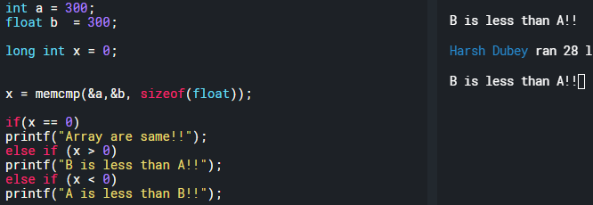

**Let’s make our own memcmp function:**

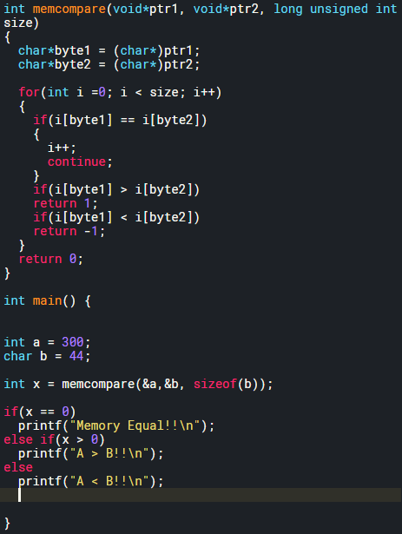

1. **Memcpy():**
2. **Pointers and Data Structures:**
3. **Stack using pointers:** Grows up. Last element empty.

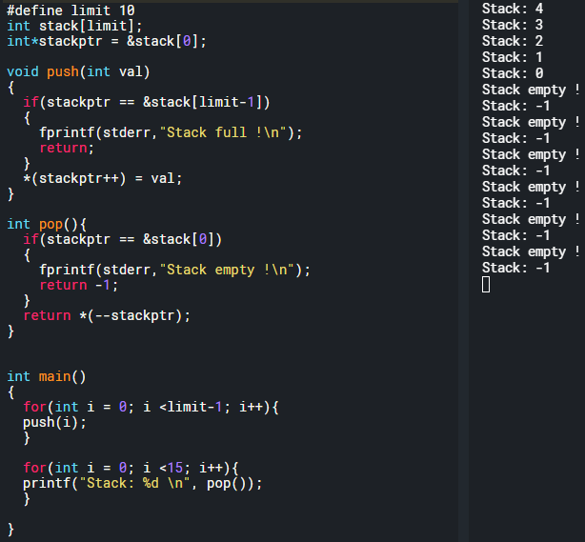

1. **Queue using pointers:** pushptr and popptr
2. Pushprt > popptr:
3. Pusptr reaches the top:
4. Pushptr == popptr : we can’t pop
5. Popptr reaches the top
6. Popptr > pushptr:

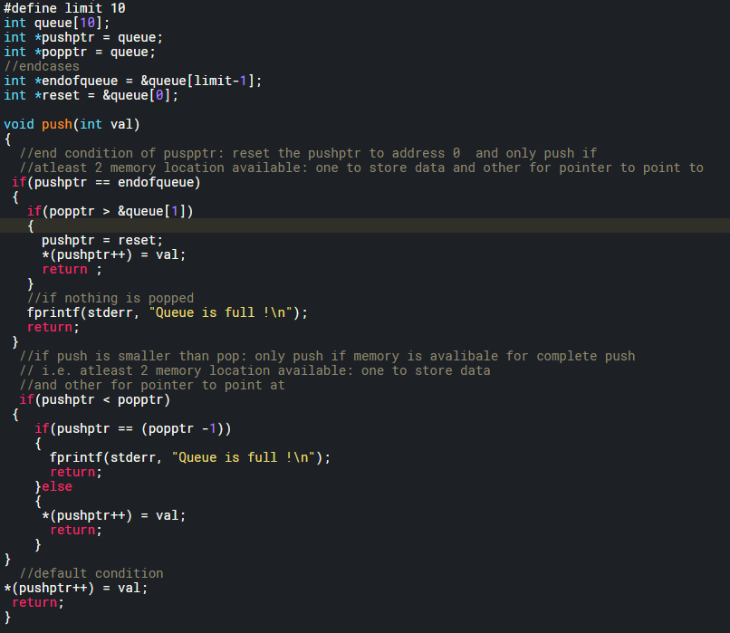

**Strings:**

1. **What are pointers? Address**, pointers are **ADDRESS also called REFERENCE**. Don’t think of them as anything else.

**Struct: Data Structure**

**What kind of data structure is a struct:** It’s your kind of data structure?

1. **Data type:** Are one unit of data structure.
2. **Arrays:** are multiple units of same data type joint together and can be indexed using a pointer.
3. But what if I want to **create** a **data structure that can store** multiple **different data types**: use **struct.** What if we **want to return two or more same or different value from a function**? Use **structs.**

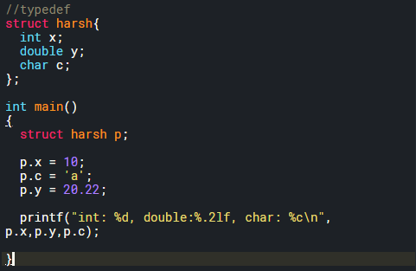

1. **How to declare and define the struct at the same time as other data types:**

* **Caveat: Initialize the data type** in the **same order** as in **definition of struct**, or else undefined **behavior.**

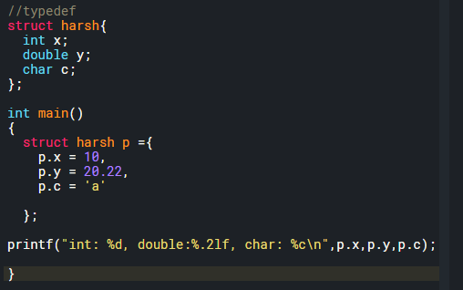

1. **How to use it like other data types:**

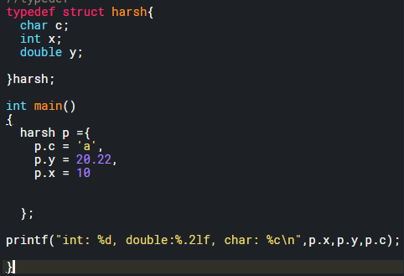

1. We can also **declare** them **individually without the order restriction.**

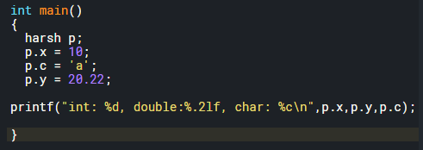

1. **What is type def doing:** Let’s break down the structure.
2. **If we look at typedef structure, then we can see that it is** typedef – datatype – rename.

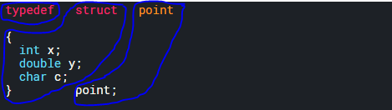

1. **Basically, we can rename any other datatype.**

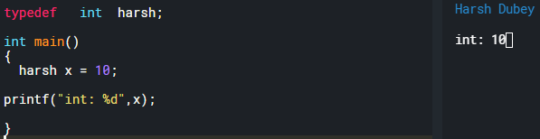

**Question:** Check if you can declare a structure as static.

**Question: Pointers to struct.**

1. **How to pass in structure to a function:** Why? We want to return two or more values from the function.

**Link List:**

**What are Link Lists:**

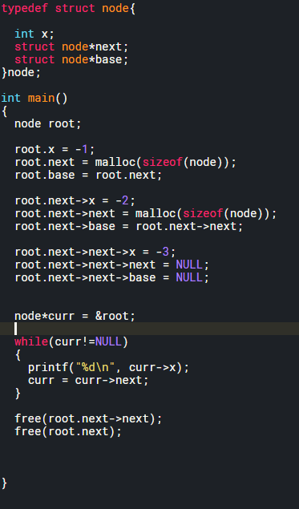

**C Interview questions:**

1. **Null pointer:** Pointer that points to nothing. Why we need it? So that there is no garbage value assigned to our pointers.
2. **Void pointer and limitations of void pointer:** It can point to any data type. Ex, can hold address of integer, float, char. But can’t be used without doing type casting.
3. **Interrupt latency and how to reduce interrupt latency.:** Time b/w last instruction of interrupted task and first instruction of ISR or interrupt handler.
4. **What is interrupt dispatch latency?**
5. **Volatile keyword.**
6. **Can we make a pointer volatile?**
7. **Printf and malloc inside an ISR?**
8. **Can we use breakpoint in an ISR?** You can surely debug the code using it but no guarantee for real time performances.
9. **Nested interrupt? Interrupt inside another interrupt. High in low.**
10. **What is embedded C?**
11. **What are real time systems and RTOS?** Logical correctness of the system within the time constraints. OS that can support real time operations.
12. **Types of RTOS: Hard** (Air bags), **Firm** (Quality decreases) **and soft** (can miss the deadline).
13. **Features of RTOS:**
14. **RTOS overhead time:**
15. **Inline function: C++ not in C.**
16. **Static variable**: Block and Automatic variable
17. **Why can’t we debug the static function**? They become inline since the compiler knows more about them and hence becomes really hard to debug.
18. **Priority inversion**.
19. **IPC mechanism**: Pipes, FIFO, Message-queue, shared memory, common files, socket
20. **FIFO vs PIPE**:
21. Inter process communication vs Communication between the processes that have a same ancestor.
22. Can independently read and write, read and write happen at the same time.
23. Can give u control and ownership, no control or ownership.
24. Half duplex vs simplex.
25. Can exists after process dies and can’t exist after process dies.
26. ## operator or Token pasting: takes two arguments and concatenate two arguments together.
27. **Forward referencing wrt to pointers:** Memory for pointer is created but it won’t know which data type it will point to.
28. **How to code infinite loop:** while (1) and for (;;)
29. **What is static linking:** Linker will link all the libraries and link create an executable image. This can port across system where the libraries might not be present.
30. **What is Dynamic linking:** You just have the name of the libraries and they are linked when the execution starts.
31. **Wild pointer:** Pointer which is not initialized.
32. **Dandling pointer:** Pointing to object that doesn’t exists.
33. **Near pointer:** Bit address up to 16 bits only.
34. **Far pointer: 32 bits** or typically a pointer that can access information outside a given memory segment.
35. **Register storage class:**
36. **Malloc() and calloc():** Malloc() is used to allocate one block of memory and calloc is used to allocate multiple blocks of memory.
37. **When to use realloc() and any specific condition available for the same:** When you want to reallocate the memory but keep the data intact.
38. **Why segmentation fault happens:** Memory violations: Stack overflow, try to write to read-only memory, improper use of scanf.
39. **Segmentation fault vs core dump:** Core dump is a file that is written when a program crashes or a segmentation fault happens. So that the programmer.

**Dynamic memory allocation:**

**Malloc and realloc:** Malloc allocates a **chunk of memory** and **returns void pointer** to the starting address of memory location. Why void pointer? Bc it doesn’t know what it’s pointing to.

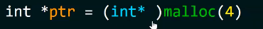 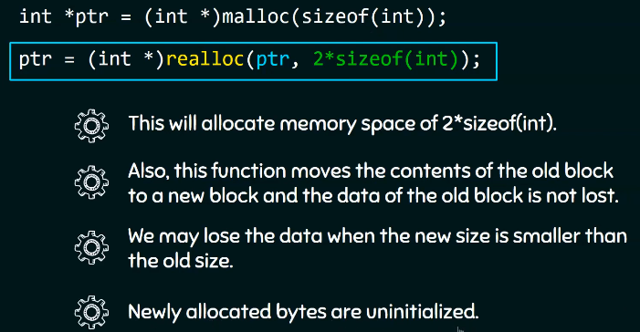

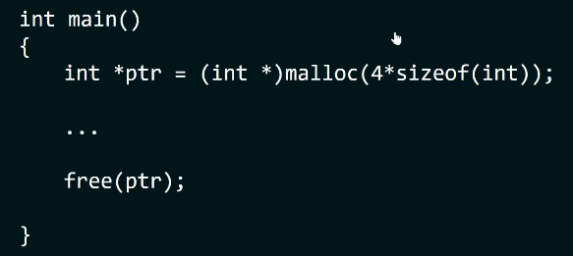

**Oscope basics:**

1. **Edge Trigger:** Trigger when to collect the data. You can bring the trigger knob down to stop the running waveform or you can trigger on rising or falling edge.
2. **Pulse trigger:** Trigger if the pulse is less than, equal to , or greater than the entered pulse width.
3. **Mode:** Auto and normal.
4. **Auto mode:** The oscope will trigger even though it’s not in triggering setting. (knob is not on the wave form)
5. **Normal mode:** Last captured waveform.

**Logic analyzer:**

1. Hate logic analyzer: Doesn’t show what’s actually happening.
2. Timing analysis vs State analysis.
3. Timing analysis: Have to provide internal clock. Asynchronous mode.
4. State analysis: Have to provide external clock. Synchronous mode.
5. Sampling memory: sequential sampling vs compression sampling.
6. 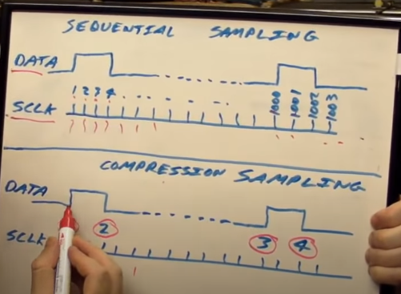

**Take home challenge:**

1. **Readme file:**
2. **Contributors:**
3. **Brief description and Introduction:**
4. **Planning:** Whatever planning went before the actual code.
5. **Technologies used for the code:**
6. How to do running and debugging.
7. Future improvement. What if there was more time?
8. **Unit test and integration test:**